Smart Hydro 2025

Group Members
Student Number | Full Name | Roles
ST10033223 | Christopher Bartie | Frontend Developer
ST10085279 | Wiehan Smalberger | Backend Developer
ST10316473 | Jessica van Heerden | Project Manager
ST10287325 | Amber Boucher | Hardware Engineer
ST10248146 | Hannah Terblanche | LoRa Engineer
ST10085428 | Keely-Ann Maritz | Secretary / Quality Assurance (QA)

Scrum Agile Board
Link: https://app.clickup.com/9012990485/v/b/7-9012990485-2
Frontend: https://app.clickup.com/9012990485/v/b/4-90124095727-2
Backend: https://app.clickup.com/9012990485/v/b/4-90124095763-2
NB: If private, email will be sent to coordinator to gain access.

GitHub Source Code Repository
- WebAPI: https://github.com/SmartHydro2025/WebAPI.git
- Android App: https://github.com/SmartHydro2025/Android-App.git
- Arduino Tent: https://github.com/SmartHydro2025/TentCode.git
- LoRa: https://github.com/SmartHydro2025/LoRa.git

Table of Contents
Contents
Group Members 1
Scrum Agile Board 1
GitHub Source Code Repository 1
Introduction 2
Introduction to the Project 3
Ethical and Privacy Considerations 3
Project risks 4
Work Agreement 4
Conflict Resolution: 5
Roles 5
Definition of Ready (DoR) 6
Definition of Done (DoD) 6
Roadmap (High-level plan) 7
Requirements 8
User Roles 9
User Stories 9
User Experience Map 11
Non-Functional Requirements 12
LoRa Requirements 13
Security 13
Performance 13
Scalability 13
Usability 13
Reliability 13
Structural Requirements 13
Scalability 14
Compatibility 14
Performance 14
Arduino Hat Requirements 14
Usability 14
Scalability 15
Performance 15
Analysis of Artifacts 15
Domain Modelling 16
Domain Modelling Description: 16
Design Artifacts 16
Motivation to why the system is structured like in the Design Artifacts Diagram: 17
Design Artifacts Description: 17
Implementation Documentation 18
UML Sequence Diagram 19
Sequence Diagram Description: 21
UML State Diagram 23
State Diagram Description: 24
Data Schema Documentation 25
Entity Relationship Diagram (ERD) 26
ERD Description: 26
My SQL Database Scheme 26
Database Schema Description: 28
Architecture Artifacts 28
Design Patterns 29
Android App 29
WebAPI 31
Arduino Controller 33
Architecture Patterns 34
Android App 35
WebAPI 36
Arduino Controller 37
Cloud Architectures 39
Docker 40
Oracle VM 41
Mosquitto Broker 42
Architecture Layout 43
Data Structures 44
Security 45
Threat actors 46
Threat vectors 46
Implemented Security Measures 47
Digital Ocean Ubuntu Virtual Machine (VM) 47
DevOps and Pipelines 47
The MQTT Protocol 47
How does the MQTT Work: 48
Authentication 48
DevOps 49
Continuous Integration Pipeline 50
Pipeline Reports 50
Running Costs 54
User growth 55
Technology Scaling 55
Scaling Infrastructure 55
Alternative Technology 55
Cost Table 56
Predictive Cost Model 57
Change Management 57
How and why will the organization adopt your software? 58
How and why will the users adopt your software? 58
What is your strategy to gain adoption from both the organization and the users? 58
Conclusion 59
Appendices 60
Appendix A: Approval Document 61
Appendix B: Rubrics 62
Declaration of Authenticity. 63
ClickUp Board 67
References 67

Introduction

Introduction to the Project
Smart Hydro is a project dedicated to supporting traditional communities living in desert regions, such as Namibia. Smart Hydro’s goal is to help these communities, by still respecting their traditional ways, to securely have a supply of nutritious crops for their families and livestock.

Smart Hydro main goal is to be able to prove that a beneficial crop, known as Lucerne, can be grown with the system. Smart Hydro’s hydroponic system, with the aid of IoT systems, will allow monitoring of the environmental conditions in the desert to make sure that this crop will grow.

Furthermore, since there is no cellular communication in those types of regions the implementation of LoRa, a communication gateway, was considered. This will allow the community members to be able to stay connected to the system via radio signals.
With Smart Hydro, there is hope that blending modern day technology with traditional ways will strengthen the food security in these communities for the time to come.

Ethical and Privacy Considerations
In the digital time that we are in, it is very important that the client’s information will be protected and used in a manner that is respectful by maintaining confidentiality.
While developing Smart Hydro system, these are the considerations we have identified. We keep in consideration that we are working with both modern farmers and traditional communities.

Informed Consent
It is important that we start off being by asking our client for consent and be transparent with what we are going to do with the data (ForumCosmos, 2023). The users will be clearly told what data will be collected, why it is being collected and how it will be stored (ForumCosmos, 2023).

Data Minimization
We have limited the data that only the essential metrics will be collected for our systems function. We collect sensor readings, hardware statuses and tent information. No personal data will be collected (ForumCosmos, 2023).

Data Security
As a group, we have an ethical responsibility to make sure that data we store will be secure. In the security section, our primary security measures are mentioned. It includes:
- Authentication
- Data Protection
- Access Control

Project risks
Smart Hydro 2025 risk management matric is based on the RAM that was taught in Project management (Gido, Clements and Baker, 2018).
Risk | Impact | Likelihood of Occurrence | Degree of Impact | Action on trigger | Responsibility | Response Plan
The client requests new features | System will have to be updated so that it meets the requirements of the client. | H | H | Client requests new feature after sprint | Project Manager  (Jessica) | All requests are considered and is discussed at next sprint meeting
Students start to become unavailable at critical moments | Individuals in teams will have to take a heavier work load. | H | H | Exam/Test week approaches | Project Manager  (Jessica) | Plan and distribute an fair amount of workload to members to ensure that none are overworked.
Arduino hardware starts to fail | The hardware of the hydroponics stop controlling the environment for our structure | M | H | No reading comes from one of the sensor components | All members | Replace components with low cost, easily replaceable components.
The VM starts to fail | The microservice wont be running | L | H | The Android application shows “Service Error” | Backend Developer (Wiehan & Keely) | Use Docker so that the whole backed services will be redeployed in minutes, once the VM is back up.
Usage of Data is too High | It will become costly to run the Tent Box on Wifi Router | L | H | Data Usage is more than 1.5Gb a month | All members | Lower the amount of times MQTT picks up the messages from the ESP.

Work Agreement
The team’s agreement with our client, Reece, is to work on an already existing hydroponics project, SmartHydro. Our team is tasked to implement new features to build onto the existing system. The required new features needing to be implemented is LoRa and a new mobile application. Our team is tasked with additional requirements such as improving the maintenance of the existing system and architecture.

Conflict Resolution:
As a team we have come to an agreement that disagreements may occur in the group. We had a process that we follow started by addressing the issue with each other. Secondly, if it was still not able to be resolved, we had a meeting that included the Project Manager so that we could have her mediate the situation. Further on if it came to where it remained unresolved, we would have an meeting with our coordinator to help us find a solution to the disagreement and prevent it from happening again.

Roles
Project Manager
- Coordinate the team
- Keep the project on track
- Make sure everyone has a good understanding of their tasks.
- Meet with the client to gain insight for any changes wanted from the client.
- Assign tasks to members based on their skills and availability
- Communicate any updates to ensure the project is aligned with the client's expectations

Secretary
- Design a Figma prototype for the Mobile Application
- Assist the team members with coding the API endpoints
- Assist with the configuration of the VM, connecting the MQTT server
- Assist team member with the creation and connection of the database

Back-End Developer
- Assist in developing API endpoints
- Help set up and configure the VM for MQTT to be set up
- Assist with creating and connecting the database to the system
Front-End Developer
- Design Front-End for the mobile app
- Maintenance of structures
- Help develop API endpoints

Hardware Engineer
- Design and develop the Arduino Hat
- Build Arduino Hat prototype
- Code API endpoints among team members
- Implement API logic into the Android Application
- Troubleshoot MQTT broker issues with team members

LoRaWan Network Engineer - Full Stack Software Developer
LoRaWan:
- Research LoRaWan technologies and hardware
- Design a LoRaWan network to integrate into the existing SmartHydro infrastructure in order to allow remote monitoring and control.
- Select hardware components to be used in the network
- Set up and integrate network
- Document the LoRaWan addition to the system
Software development:
- Assist front and back-end developers on areas of the project that need more attention

Definition of Ready (DoR)
The system is considered ready to hand over to the client when all existing features have been maintained; the new features have been implemented; in-depth testing has been conducted to eradicate bugs and ensure full functionality.
The system has been tested thoroughly and is no longer running locally, i.e. the Android application is available to the client. The different hydroponic structures that are given to farmers are fully built and allow plants to grow in them, with the AI from the relay box being able to manage the plants without human intervention. Documentation is prepared for the system to be handed over to the client for them to have a good understanding of how the system works.

Definition of Done (DoD)
The system is considered done when the new and improved SmartHydro system has implemented the following: the Virtual Machine (VM) has been configured, the MQTT is connected to the VM, new APIs are integrated, a redesigned and implemented Mobile Application is created, the Arduino Hat prototype with a diagram is provided for future improvements and development, most importantly our LoRa network is integrated into the system on both the backend and frontend aspect. Each structure has been delivered and assembled on a farm by the team, and each structure works as intended with the AI taking care of the plants' needs without the need for human intervention. The documentation should be completed for future use; it will be able to give proper support for building the structure, setting up the tunnel, connecting the relay box, and understanding how the system works together. Overall, this means we should not be developing any further and our client is satisfied with the product.

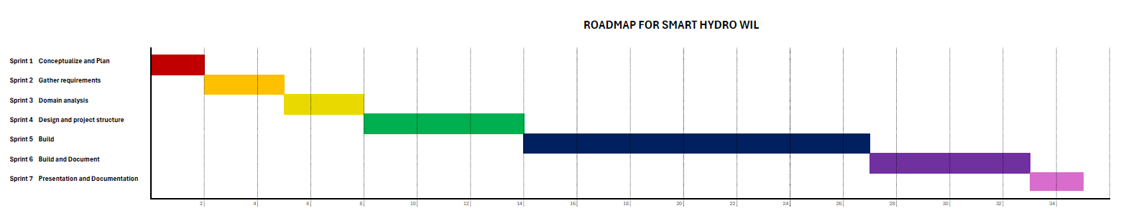
Roadmap (High-level plan)

Requirements

User Roles
Farmer
- Adds New Tent
- Selects existing tent
- Delete a tent
- View selected tent data
- View LoRa readings
- Control the tent environment
- Views Live Feed
- Mark tent as favourite
- View Frequently Asked Questions

User Stories
As a farmer, I want to add a new tent, so that I can monitor its environment and improve the growth of the plants.
Priority | High
Team Estimation | 4 points
Sprint | Design Android Frontend, Android Backend, Implementation of API's in MVC
Implementation | Implemented

As a farmer, I want to delete a tent, so that I can remove inactive tents and view my active tents.
Priority | High
Team Estimation | 4 points
Sprint | Design Android Frontend, Android Backend, Delete Tent
Implementation | Implemented

As a farmer, I want to select an existing tent to view its data and history, so that I can determine a pattern in the tent.
Priority | Low
Team Estimation | 2 points
Sprint | Design Android Frontend, Android Backend, Implementation of API's in MVC
Implementation | Implemented

As a farmer, I want to view the sensor readings instantly by clicking on a button.
Priority | Low
Team Estimation | 2 points
Sprint | Design Android Frontend, Android Backend, Implementation of API's in MVC
Implementation | Implemented

As a farmer, I want to control the tent environment by selecting the on and off buttons or increasing and decreasing buttons.
Priority | Low
Team Estimation | 4 points
Sprint | Design Android Frontend, Android Backend, Implementation of API's in MVC
Implementation | Implemented

As a farmer, I want to be able to see the live feed of my plants to make sure what condition they are in.
Priority | Medium
Team Estimation | 3 points
Sprint | Design Android Frontend, Android Backend, Implementation of API's in MVC
Implementation | Implemented

As a farmer, I want to be to access information based on hydroponics in case I am not sure about a topic.
Priority | Medium
Team Estimation | 3 points
Sprint | Design Android Frontend, Android Backend, FAQ (Structure, Plants, Box, App)
Implementation | Implemented

As a farmer, I want to be to mark a tent as a favourite to view the frequently used tent at the top of the list of tents.
Priority | Medium
Team Estimation | 3 points
Sprint | Design Android Frontend, Android Backend
Implementation | Implemented

User Experience Map

Non-Functional Requirements

LoRa Requirements
When the team started LoRa development, our client provided us with the following non-functional requirements to consider:

Security
- Data packets must be encrypted to protect against packet sniffing and attacks
  - Our LoRa engineer will design and develop our own algorithm to ensure that the binary data is encrypted before sending out data packets.

Performance
- Data displays must update with live information in 1-minute intervals
  - The LoRa communication needs to retrieve live updates regarding sensors and AI events etc. from the Arduino in a reasonable time to display to the user.
  - Communication also needs to receive and relay commands for the Arduino, including switching components on and off in a reasonable time to ensure users know the system is working.

Scalability
- Expansion of the LoRa network
  - The addition of new LoRa modules like nodes and a gateway should be accommodated for future expansion of the system into more complex scenarios.

Usability
- Readability of data displays should be of priority
  - The print out of results from user requests should be formatted in a neat manner to make understanding easy for the user.

Reliability
- Remote data collection should be possible when the relay box is connected via LoRa
  - If a user requests data from the Arduino, the data should be retrieved and returned when there is a connection to the box.

Structural Requirements
During each iteration of structure assembly and construction, the team had to consider the following aspects to ensure that setting up the structures during hand-over would be possible:

Scalability
- Modular design for possible addition of trays or rows for plant growth and sensors for the box
  - All physical systems need to consider how easily it can be accommodated to allow addition of existing components.
  - For example, addition of more rows in the fodder tent to grow more fodder within the same 2-week sprints or different sensors like flow rate sensors to be added to the relay box.

Compatibility
- System should be stable and resilient regardless of terrain and climate conditions
  - The fodder structure needed to be built with different environmental factors in mind, in our case considering the desert with high humidity and lots of sunlight whereas the grow tunnel needed to withstand strong winds.

Performance
- Minimal power consumption within 24-hour cycles
  - The relay box switches grow lights, and water pumps off after specific intervals to ensure power and resources, like water, are not overconsumed.
  - Considerations of implementing solar power to the relay box to lessen the reliance on electric power.

Arduino Hat Requirements
The team had to consider the following non-functional requirements when the design and assembly of the Hat started:

Usability
- Port names and numbers labeled on board to ensure understanding
  - Users will see labels of which components are where to ensure that connections from the hat to the corresponding component are correctly made.
- Ribbons of cables for easy identification of individual components
  - Each component will have sets of cables connected to the board to ensure that connections are easily identified and understood.

Scalability
- Allocated space for addition of pin headers for expansion
  - The board will allow space considerations for future sensors and components to be added onto the system which needs to be connected to the board.

Performance
- Onboarding of external power supply
  - The board needs to accommodate external power supply to ensure that relays and other components receive the required power supply to ensure the system is powered

Analysis of Artifacts
The following section outlines the technical design for the Smart Hydro system. It describes how the database structure and architecture flows. Domain modeling defines database structure. It explains the relationship between the tables and their relationships. The design artifacts explain the operational logic of the system.

Domain Modelling
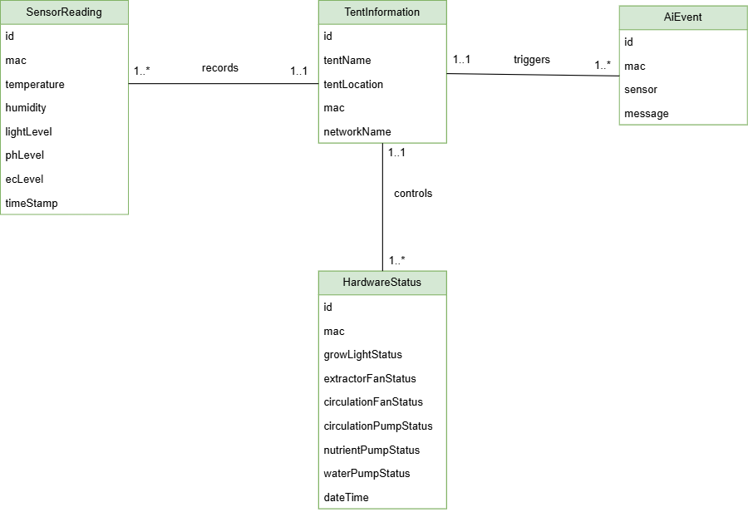

Domain Modelling Description:
The Domain class diagram displays the MySQL database of table names, attributes, and the relationships between the tables. A one-to-many relationship exists between the TentInformation table and the following tables: SensorReadings, HardwareStatus and AiEvent. The diagram fields are identical to the database table fields, serving as a blueprint.

Design Artifacts
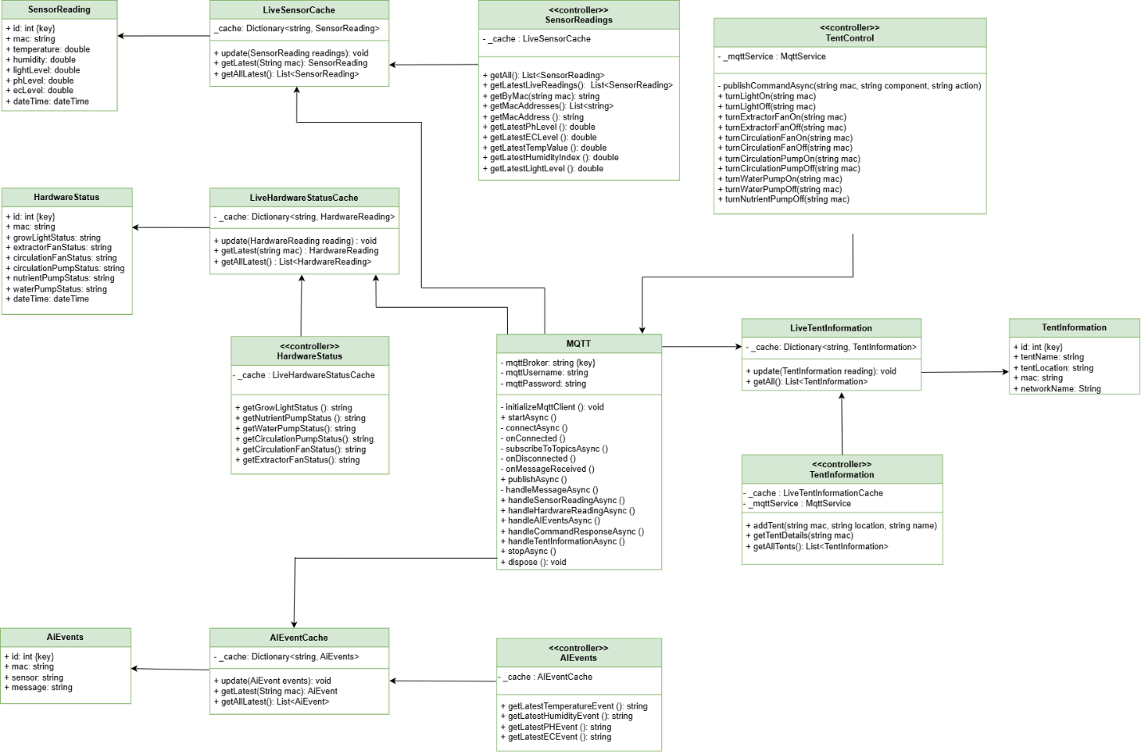

Motivation to why the system is structured like in the Design Artifacts Diagram:
The system needed to be hosted on a platform, allowing anyone to access it, without needing to run on physical devices. A Virtual Machine (VM) was chosen to implement micro-services, allowing the MQTT, Web API and MySQL relational database to be dockerised. The Virtual Machine hosts the MQTT, Web API, and MySQL relational database. If a problem arises with the micro-services, a developer can access the micro-services on the VM remotely. The MQTT was implemented as it assists with organization and faster communication with the Web API, subscribing to topics such as Sensor Readings, Ai Events, Tent Information and Hardware Statuses. The Web API will pull the topic and publish it to the Mobile Application. An Android Mobile Application was implemented to assist farmers with a user-friendly and easily accessible application to check the readings on their devices, on the go.

Design Artifacts Description:
The Design Artifacts diagram demonstrates the logic of the Smart Hydro Web API. The MQTT Server sends the data to the MQTT class in the Web API. The diagram displays the public and private accessors, keys, methods, and UML relationships.
The AiEventCache, LiveTentInformation, LiveHardwareStatusCache and LiveSensorCache classes are called in the MQTT class and in the separate controllers. The methods for the Sensor Readings, the Hardware Statuses and AiEvents get called in the MQTT class.
- The AiEvent data class is used and called AiEventCache.
- The TentInformation data class is used and called LiveTentInformation.
- The HardwareStatus data class is used and called LiveHardwareStatusCache.
- The SensorReading data class is used and called LiveSensorCache.

Implementation Documentation

UML Sequence Diagram
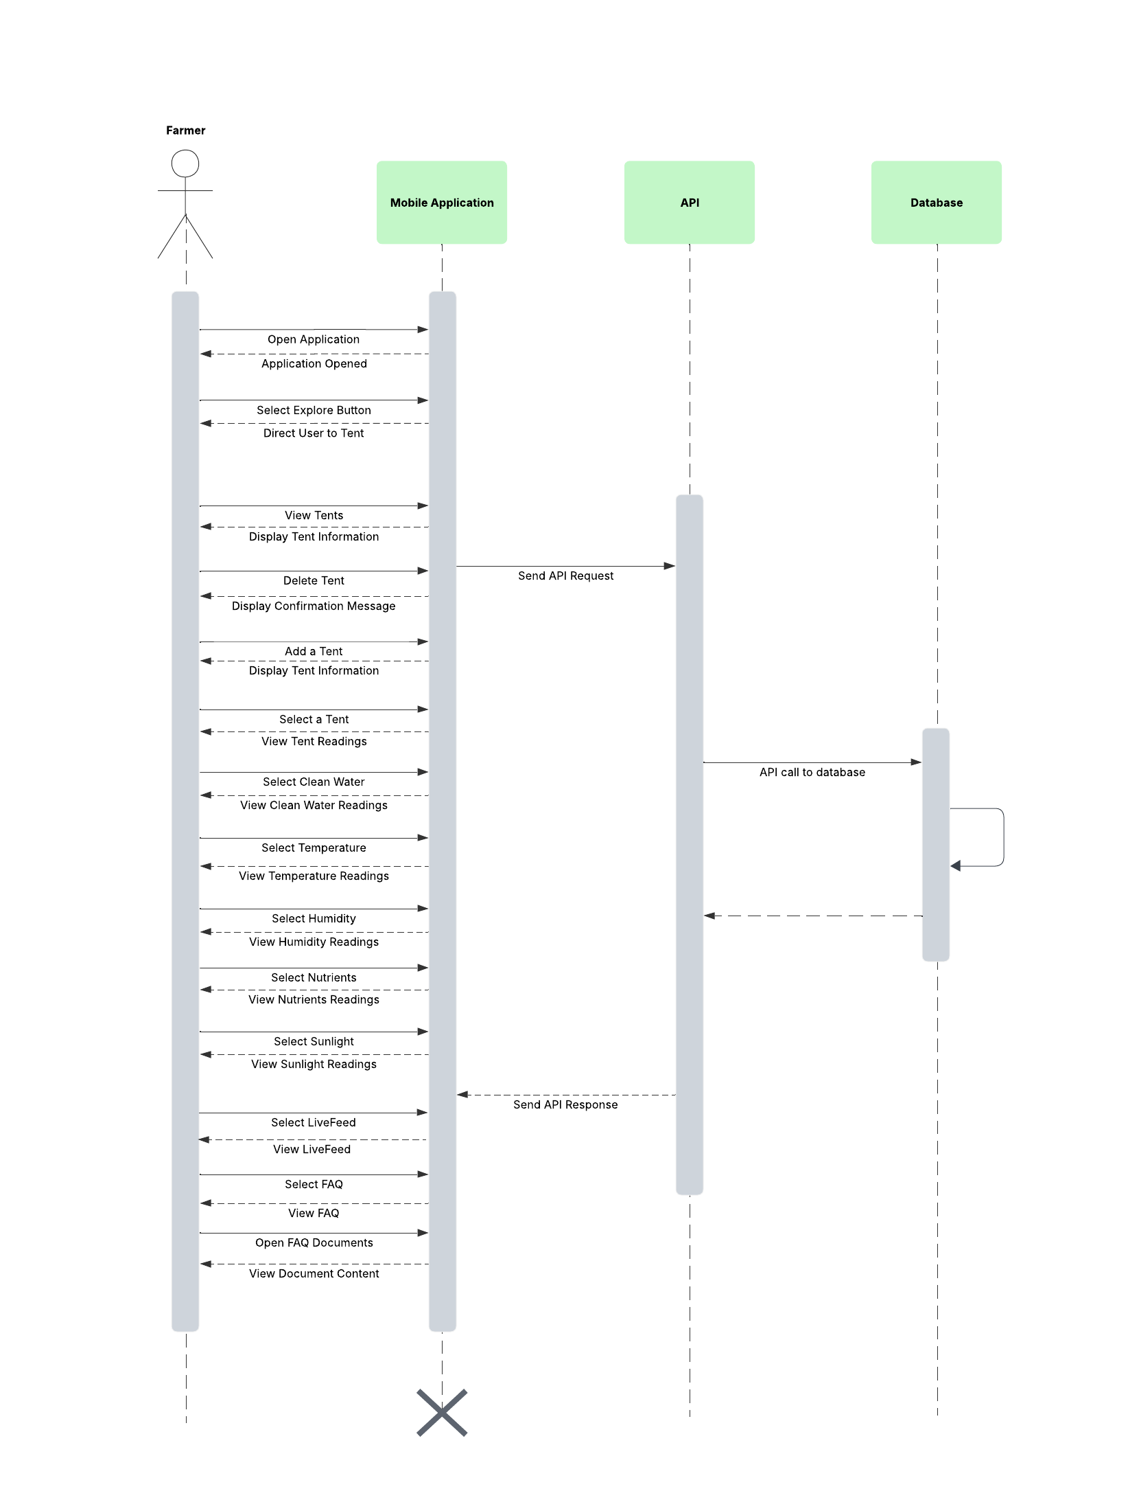

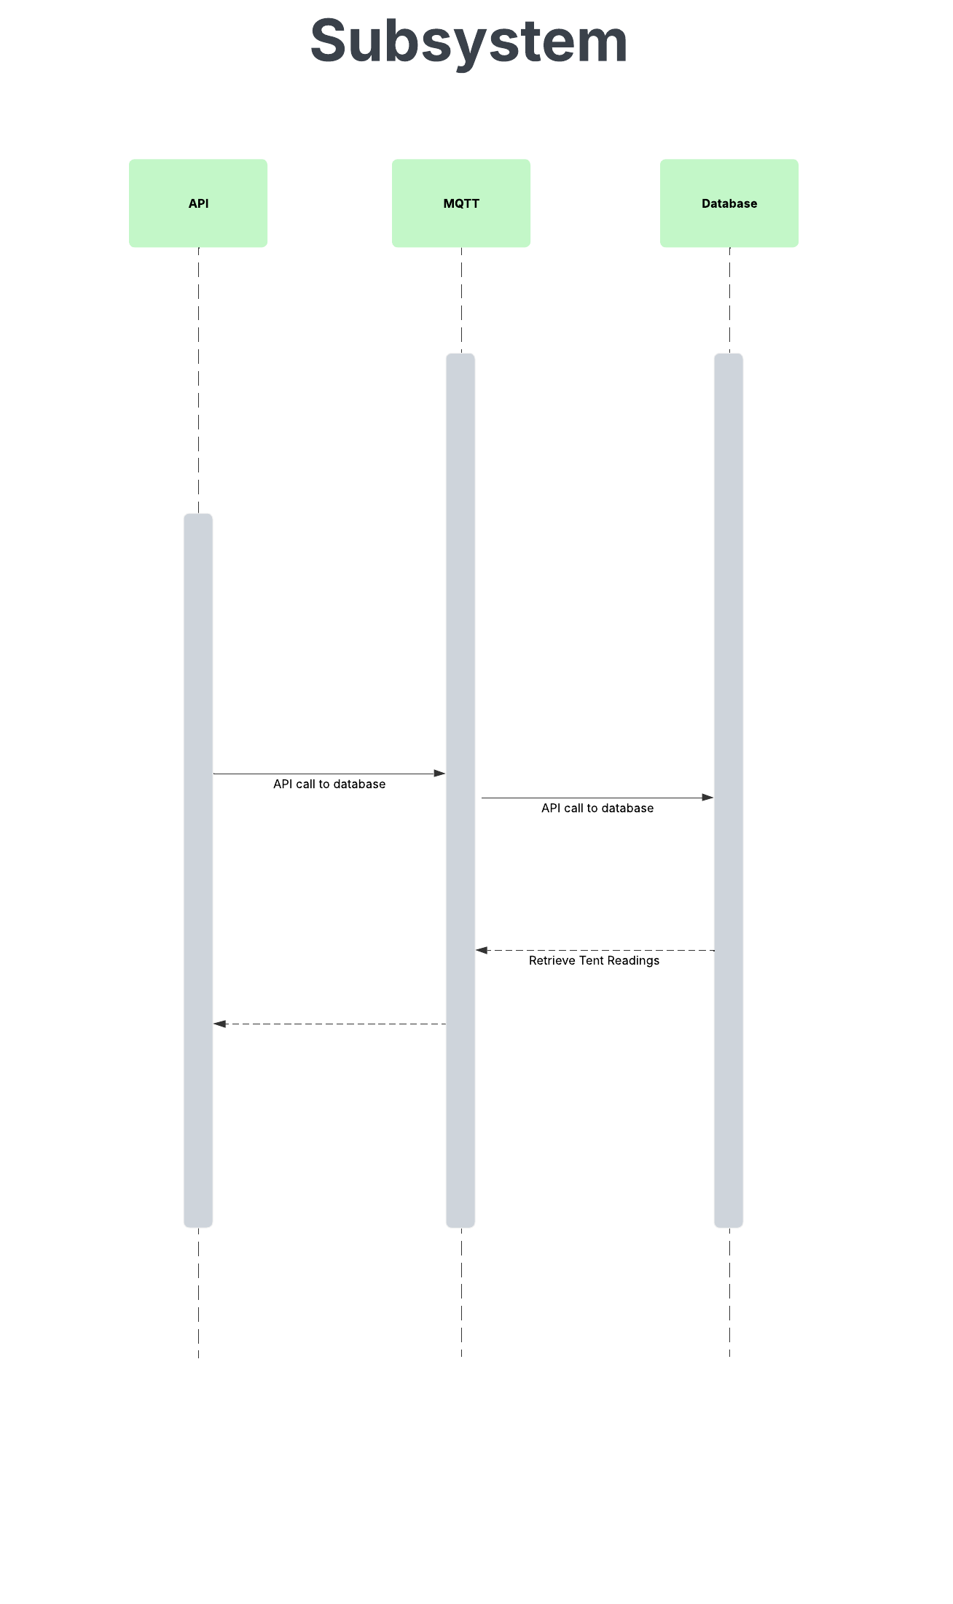

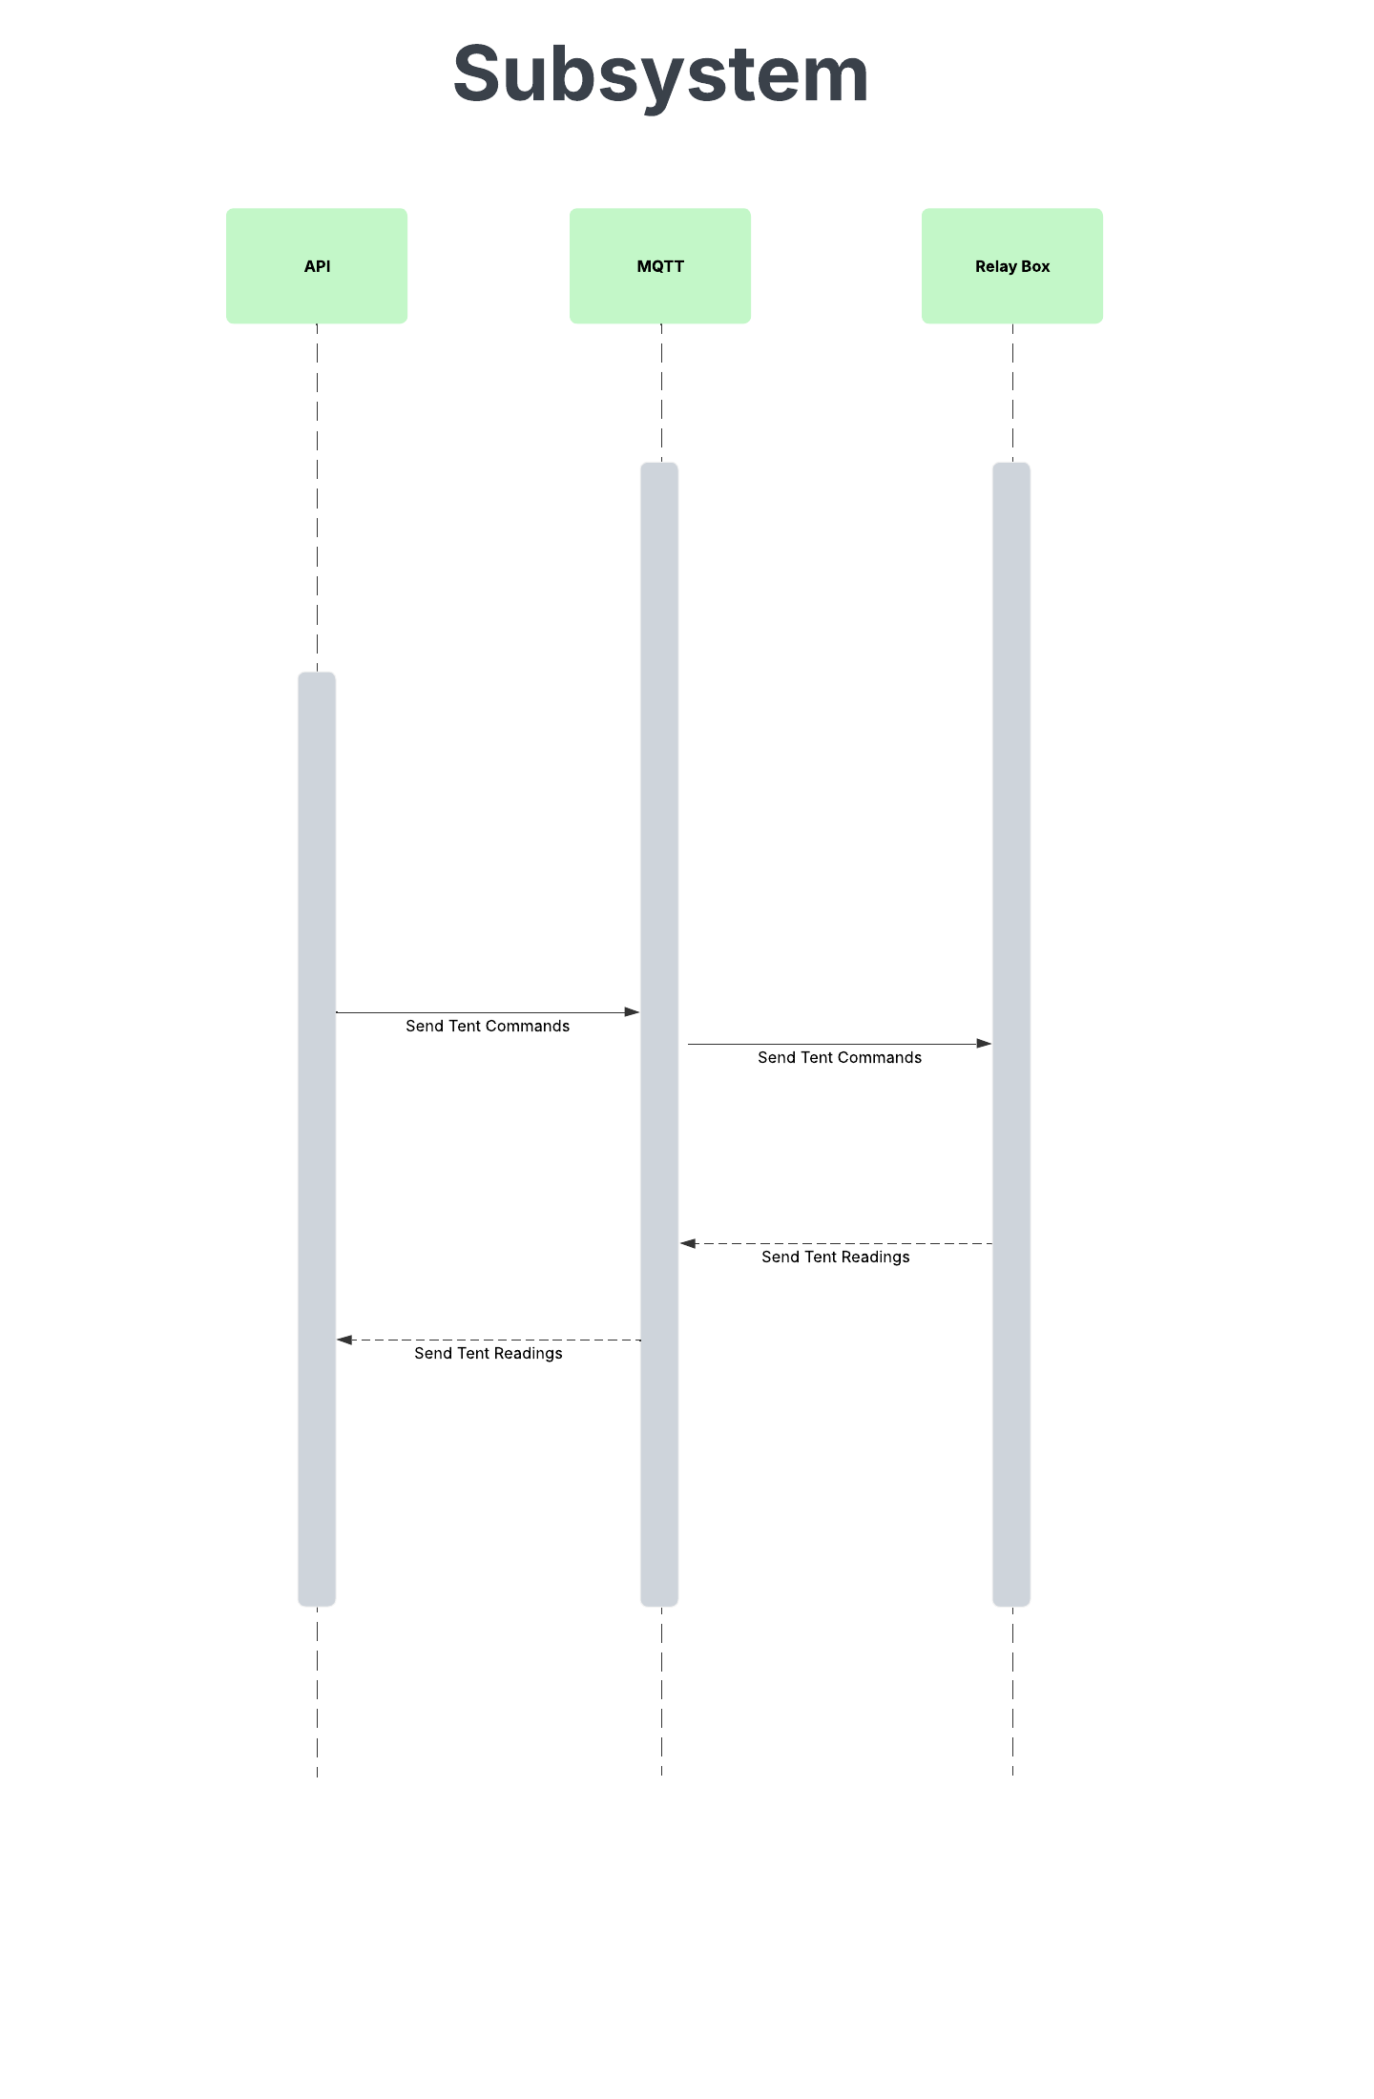

Sequence Diagram Description:
The Sequence Diagram demonstrates how the farmer interacts with the mobile application and how the mobile application communicates with the Web API and the MySQL relational database. Once the farmer opens the application, a splash screen will display before the user is prompted to select the Explore button, to view all the tents. A request is sent to the Web API, which retrieves the data and displays the tents on the mobile application, to the farmer. The farmer can choose to add or delete a tent, sending a request to the Web API to add the tent data or to delete the tent data in the database. A farmer can select a tent, where they can view all the tent readings for the specific tent. A request is sent to the Web API, which retrieves the data and displays the latest tent readings on the mobile application. A farmer can swipe down onto the screen, refreshing the tent readings and displaying the latest tent readings. A request is sent to the Web API, which retrieves the data and displays the latest tent readings on the mobile application, once refreshed.

If the farmer selects the water level, they can view the current readings and choose to switch it on or off. A request is sent to the Web API, which retrieves the data and displays the latest tent readings on the mobile application. If the farmer selects the clean water (pH level), they can view the current readings and choose to increase or decrease it. A request is sent to the Web API, which retrieves the data and displays the latest tent readings on the mobile application. If the farmer selects the Temperature, they can view the current readings and choose to switch it on or off. A request is sent to the Web API, which retrieves the data and displays the latest tent readings on the mobile application. If the farmer selects Humidity, they can view the current readings and choose to switch it on or off. A request is sent to the Web API, which retrieves the data and displays the latest tent readings on the mobile application. If the farmer selects the Nutrients (EC level), they can view the current readings and choose to increase or decrease it. A request is sent to the Web API, which retrieves the data and displays the latest tent readings on the mobile application. If the farmer selects Sunlight, they can view the current readings and choose to switch it on or off. A request is sent to the Web API, which retrieves the data and displays the latest tent readings on the mobile application. To view the AI Events and the live Feed of the plants, the farmer can select the LiveFeed option in the navigation bar. A request is sent to the Web API, which retrieves the latest LiveFeed results, displaying the data for the farmer on the mobile application. If the farmer is experiencing an issue, they can select the FAQ option in the navigation bar to find a solution. Once they have selected a FAQ, they can click on the document and view it. The mobile application is closed by the farmer, once they have completed using the application.

The first subsystem demonstrates the connection between the Web API, MQTT, and the MySQL relational database. The Web API retrieves the tent readings from the database. The second subsystem demonstrates the connection between the Web API, MQTT, and the Relay Box. The Web API sends tent commands to the Relay Box, executing the commands. The Relay Box sends the tent readings through the MQTT to the Web API, which will store the readings into the database.

UML State Diagram
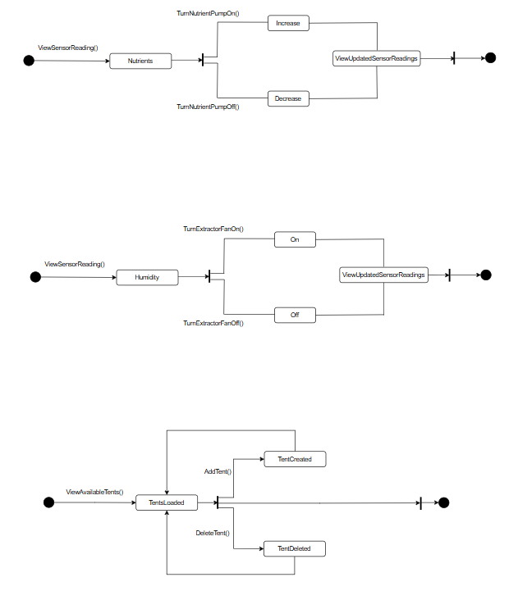

State Diagram Description:
The Nutrients diagram demonstrates the flow of viewing the sensor readings and how the nutrients would increase, and decrease based on the button selection. The sensor readings would be updated, and the latest readings will be displayed to the farmer.

The Humidity diagram demonstrates the flow of viewing the sensor readings of the humidity, when the farmer turns the extractor fan on and off. The sensor readings would be updated based on button selection, and the latest readings will be displayed to the farmer.
The last diagram demonstrates the flow of how the farmer adds and deletes tents on the available tents page. If the farmer adds a new tent, the available tent page would display the new tent the farmer added. If the farmer deletes a tent, the available tent page would no longer display the tent. If the farmer does not wish to add or delete a tent, they can view all the available tents.

Data Schema Documentation
In this section, the sequence diagram shows how the farmer will interact with the mobile application. The mobile application then communicates with Web API and database to manage the tent data. The Web API then retrieves data via MQTT so that each tent will show the latest readings.

Entity Relationship Diagram (ERD)
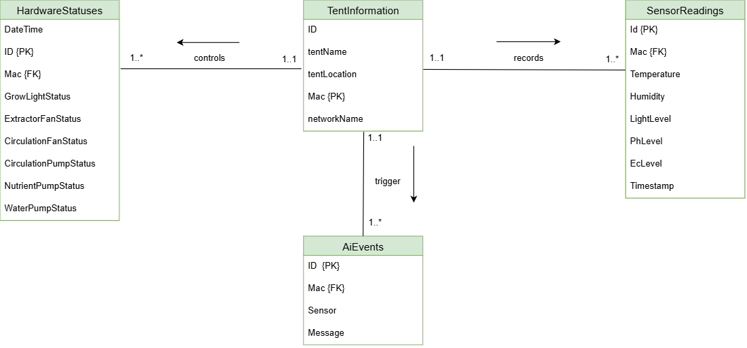

ERD Description:
The SmartHydro team members implemented a MySQL relational database onto the Ubuntu Virtual Machine (VM). The MySQL database connects to a Web API. The database is used to store tent information, sensor readings, Ai event messages and hardware statuses. The entities have one attribute in common, the Mac Address. The Mac Address uniquely identifies the tent.

My SQL Database Scheme
Link to SQL Schema:
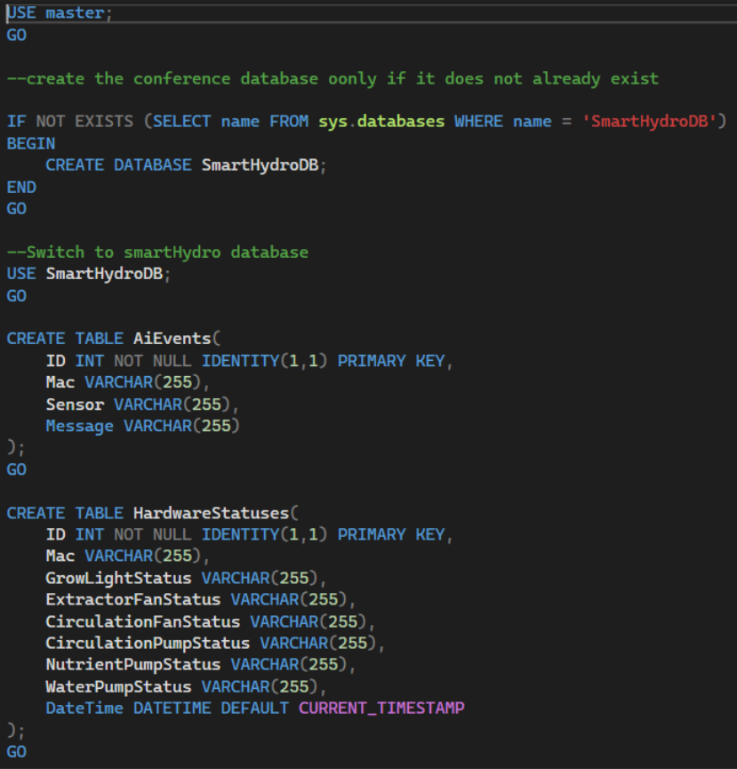

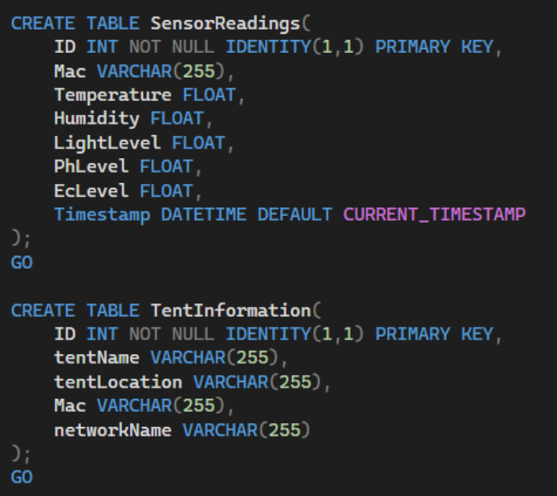

Database Schema Description:
The MySQL relational database was created locally using MySQL workbench, for testing. We installed the MySQL server onto the Ubuntu Virtual Machine (VM). The following MySQL schema was used to create the MySQL database tables.

Architecture Artifacts
The Smart Hydro system has various integrated components including the Android App, the WebAPI, Arduino setup, an MQTT broker as well as an SQL database. Of these components, the WebAPI, Mosquitto Broker and SQL database are Dockerized and hosted on an Oracle VM. The overall system takes on a hybrid approach across these components that have been built to ensure all parts seamlessly work together. This section will cover in detail the different architecture, design and cloud patterns that have been implemented along with explanations regarding choices for the NMB campus system.

Design Patterns

Android App

Singleton Pattern
The pattern that ensures only one instance is created and used throughout the lifetime of an object is known as Singleton (Refactoring Guru, 2025). Smart Hydro uses Singleton for connecting to the various WebAPIs namely Durban's with local connections and NMB's with the MQTT set up. Figure 1 below shows how a Singleton Pattern keeps one instance of itself when different classes interact with it:

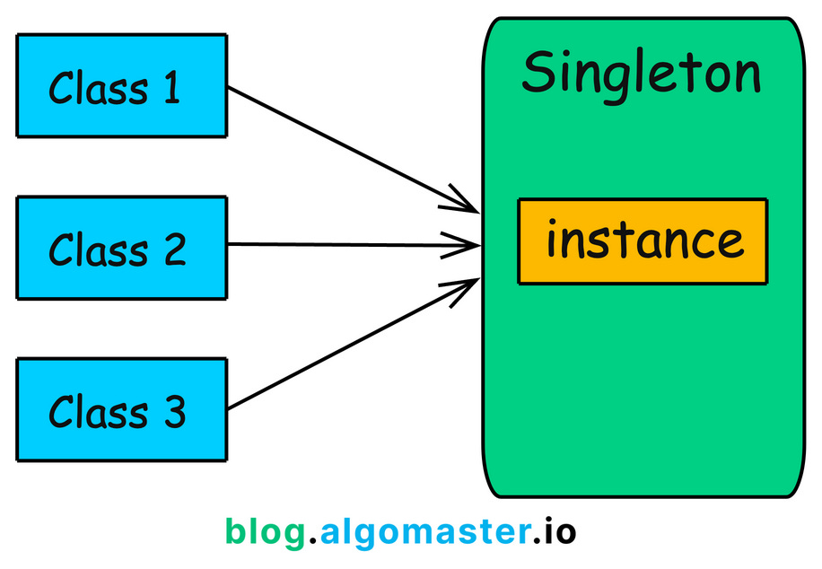
Figure 1: Singleton Pattern (Singh, 2024)

A Retrofit Instance is created that configures the different endpoints from the APIs based on which system is selected in the Android app. This means Retrofit Instance creates one single connection to the MQTT API and one single connection to the Durban API. This allows the Android app to dynamically switch between the backend systems allowing the app to access the correct endpoints and reflect the corresponding data.

These instances of API connections are then used throughout the app to make the correct requests to the correct API as needed; this means the API connection does not change throughout the lifetime of the app, it is configured once and used as is (Refactoring Guru, 2025).

Why Singleton:
- Global access means the entire Android app has access to the APIs which allows endpoint to receive requests from all necessary points within the project (Grimm, 2022).
- Update management if the APIs are hosted outside of its current VM environment, their IP addresses in the connection URL will change and will only have to be updated in one central location and ensure the rest of the app will connect to the correct URL if it is updated where it is configured (Grimm, 2022).
- Memory is freed with less objects cluttering it when Singleton is implemented a sit makes use of only one class that creates only one object that is reused throughout the project meaning less memory is occupied in this system (Mahammad, 2020).

Strategy Pattern
A behavioral pattern that assists with different behaviors being restricted to different classes and making them interchangeable at runtime (Kartik, 2025). In Smart Hydro's case, there needs to be a switch between backend API code bases which needs to change based on which type of box the app is currently connected to. This means the Strategy pattern helps to decide which API should be used depending on the system that is connected. Figure 2 shows how a Strategy Pattern decides at runtime which behaviors to apply:

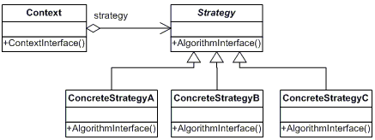
Figure 2: Strategy Pattern (Poorte, 2024)

There is an API (Durban) that works on local connection to the Arduino Controller, meaning an access point that does not connect to the internet is produced by the box and the app connects to that to display data. On the other hand, there is an API (NMB) that uses an MQTT server and sends readings over the internet. Different relay boxes have been configured to run each campus' system, and the Android app needs to adapt for both.

Why Strategy:
- Interchangeable code is necessary for the Smart Hydro system because various types of connections are implemented meaning the app needs to be able to accommodate for any connection without needing to reboot the app or design a separate, entirely new app to handle the different code bases (Junhua, 2021).
- Decoupling allows the different backend code bases to exist independently where the way in which API behaves remains separate from the other so if one changes, it will not affect the other (Junhua, 2021).
- Scalability ensures that ore Strategies can be added to an existing system without having to modify the original code that interacts with the existing Strategies; Smart Hydro can develop another Strategy to handle the local connection and internet connection in one box, which was also developed for this system, and add on a Strategy that handles how that API interacts with its data (Junhua, 2021).

WebAPI

Repository Pattern
The repository pattern is used to decouple domain logic from the database layer in order to make it more flexible for data management, i.e., it allows a central point of interaction and access to the database to reduce duplication of create, update and delete methods (Genfer, 2025).

In Smart Hydro’s case, the repository pattern is implemented through using the Live Cache classes for various data that is required from the Arduino (that is accessed through the database) and allows for data to only be posted, updated and deleted from the live cache classes.

This prevents duplicate methods to interact with the data from the database whilst still ensuring the data remains up to date. Figure 3 below shows how a repository pattern assists with central data interaction because the source where data comes from interacts with the repository and the requests for data reach the repository to access the data:

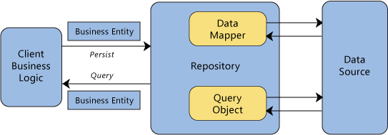
Figure 3: Repository Pattern Diagram (Anwar, 2009)

Throughout the controllers in the WebAPI, when data is requested form the database, the API will first update the cache to store the latest readings of the current tent (determined by the Android app) and then send out a response to the client requesting the data.

The system is dependent on the most up to date readings such as hardware statuses which can change when a new tent command is logged to the API meaning data must be updated, but if the data is updated in multiple places throughout code, this can cause management issues as the system evolves and scales up (Genfer, 2025). A central place for data control simplifies both the management of incoming and outgoing data as well as the understanding of set ups as the project is handed over to a new team to improve upon (Genfer, 2025).

Why Repository:
Consistency is emphasized throughout the system because the data access logic is centralized, meaning every component in the API is interacting with data in the same way by manipulating the data and proceeding to update the live cache before sending the results to the database and the end user (Patel, 2024).

Decoupling ensures that the organization of code in the backend is cleaner and easier to follow as the data access logic remains separate from the business logic ensuring the repository is kept separate from the rest of the API so that all interactions to data are easy to find (Patel, 2024).

Flexibility is supported because the data access technology can be experimented with or changed for another like switching from JOOQ Objects to Entity Framework without affecting the overall business logic because they are separate from one another (Patel, 2024).

Arduino Controller

Observer Pattern
An observer pattern is defined as a behavioral pattern that allows objects to be notified when there is a state change (Cookies, 2024). Updates are automatically applied to an observer when a subject’s state undergoes a change meaning that the objects are synchronized (Kartik, 2025).
Within the Smart Hydro system, all components depend on real time, quick updates as hardware or sensors experience change for example, an AI event turning the circulation fan on because the temperature was detected as too high for the tent. Figure 4 shows how a subject sends out notifications on state change to all its observers:

Figure 4: Observer Pattern Diagram (Cookies, 2024)
The Arduino sensors are responsible for detecting changes in the environment inside the tent or tunnel as well as requests to make changes from the API switching hardware on and off. This means, any object that can be affected by the change in state, needs to be notified and allow changes to happen like the hardware detecting a change in temperature of humidity and toggling the respective components on and off to adjust the environment to more favorable conditions.

Why Observer:
Automatic Synchronization is enforced meaning the end users can see almost instant updates as states change within the Arduino controller because the subject sends out notifications as the state changes, notifying all observer awaiting the change updates; these updates are beneficial to a system that is monitoring the health and status of plants when the environment has to be favorable to promote growth (Cookies, 2024).
Flexibility is prioritized because many-to-many relationships are supported so many subjects can have many observers, in this case the pH levels depend on the EC levels and the temperature in the tent so the pH will fluctuate as there is a change in temperature or nutrient solution in water reservoirs so there are at least two observers waiting for changes for the pH (Cookies, 2024).
Dynamic Relationships encourage that observers can be added and removed at runtime without adjusting the subject’s code meaning that if a subject needs more observers, it can be easily added without modifying the subject because it just needs to know that it should send out a notification to the observer objects its related to in the code (Cookies, 2024).

Architecture Patterns

Android App

Layered Architecture:
The approach of dividing software into horizontal layers to focus responsibility per layer is known as a layered architecture (Cherif, 2024). This means separating the software into the visual interfaces (Presentation Layer), the core algorithms and validation (Business Layer), data retrieval and storage (Persistence Layer) and the final storage of data from the system (Database Layer) (Cherif, 2024) with the interactions between the layers indicated in Figure 5 below:

Figure 5: Layered Architecture Diagram (Cherif, 2024)

The Android app has implemented the layered approach by dividing the user interfaces (UI) as separate from the backend that makes the interfaces functional. This means the app is not making use of JetPack Compose where the UI and the functionality is combined and heavily dependent on one another. The UI is present with the backend logic placed in a class that calls on the UI. This forms the Presentation Layer.

The core algorithms and logic are structured in methods that ensure that there are fallbacks in case of errors as well as processing incoming data to ensure it matches the expected formats. These methods that validate and handle API responses form the Business Layer.
Classes handle actions performed within the app, for example clicking a card to see the temperature rating and turn the fan on calls the API endpoint that pulls the latest temperature reading in. The API endpoints are based on the API Constants class that stores the details regarding the base URL to the API and implements OkHttp to send requests to endpoints as well as receive their responses (Jahagirdar, 2018). These classes which creates the Persistence Layer.

The data is retrieved from an SQL database that is hosted on a Virtual Machine (VM). This database is accessed through the API which is discussed in WebAPI and the data that is received through the Android app is displayed on the UI. The SQL database forms the Database Layer.

Why Layered Architecture:
- Modularity allows the layers to be adjusted and expanded upon as needed meaning if new functionality is required for the business layer for example, it can be developed independently without affecting the other layers too heavily (Cherif, 2024). This allowed for scope adjustments to be integrated seamlessly as changes were required.
- Efficiency because various developers can work simultaneously on separate layers without concern for the other layers, i.e., the UI can be developed independently, by a front-end developer, from the logic developed by a backend developer at the same time (Cherif, 2024). This was beneficial to the Smart-Hydro project as there were designated front and backend teams who were able to focus on their respective layers without causing conflicts on the GitHub repository.
- Maintainability is easier as this is an ongoing project, and bugs are isolated to the layer where they are found and can easily be resolved also leading to changes that will not have much effect on the rest of the app around that layer where a change is made (Cherif, 2024).
- Horizontal scalability allows for more layers to be added to the app accommodating for future developments that will require further data retrieval methods to be added or requiring more traffic control in the persistence layer as volume of traffic increases when system is deployed to farmers.

WebAPI

Client-Server Architecture:
This is an architecture that depends on communication between two major components, one that is known as the client that sends requests and another known as the server which identifies and responds to requests by the returning the relevant content (Dhaduk, 2020). In the Smart Hydro system, the API receives requests from the client namely the Android app as users navigate and API endpoints are called, in which data is retrieved and the requested data is fed to the client app.
The interaction of the client and server is explained in Figure 6 which shows how the client makes a request which in this case travels to the API, gets information from SQL database which sends the response back to the Android app.
Figure 6: Client-Server Architecture Diagram (Ingalls, 2021)

The client-server pattern is implemented by setting the API up to enable communication between the database server and the Android app to allow real-time data to be requested and received (Dhaduk, 2020). A client is defined as the component that sends the requests which is the Android app that makes requests to the API to retrieve and display data on the GUI (Design Gurus Team, 2024). The API allows communication to the database server because it processes the requests and retrieves any requested data to send back to the client as a response (Design Gurus Team, 2024).
The API rests between the app and the database server which keeps track of data, i.e., sensor and hardware readings, that can be accessed through the API and sent back to the Android.

Why Client-Server:
- Scalability ensures that more clients can be added to the Smart Hydro system, for example an MVC frontend app that allows admins to overlook the system and its connected tents to ensure all relay boxes are functioning as intended or an iOS app that can accommodate for Apple users. This allows the system to upgrade as requirements change over time and different components need to be added on (Zenarmor, 2023).
- Accessibility ensures that all nodes in the system are self-contained, making it easy to upgrade components individually or relocate them to a different area meaning the server can be hosted whilst the client app can be deployed, and the system remains available to users (Zenarmor, 2023).
- Easy management of the system means that the data is easy to retrieve, track and handle because any data that should be requested by the client should be stores on the same server making for easy storage of the required data, i.e., sensor readings all store to the SQL database (Zenarmor, 2023).
- Performance is of priority because the server can handle resource-intensive activities such as sending tent commands from the app to MQTT through the API which sends the command in a relatively quick time and MQTT can send the request to the Arduino for execution (Zenarmor, 2023).

Arduino Controller

Event Driven Architecture:
Systems that require real time flow of information as events occur between apps or connected devices rely on event driven architecture (Seetharamugn, 2023). These systems need to have the ability to publish and subscribe to events asynchronously by implementing a broker to handle events (Seetharamugn, 2023).

The Smart Hydro system requires reflection of changes caused by events or changes that trigger different events based on the Arduino set up that controls the hardware of the system. The communication between the broker and the system is indicated in Figure 7 below showing how the events trigger messages to be sent to consumers who have subscribed to different topics in the broker:
Figure 7: Event Driven Architecture Diagram (Roddewig, 2023)

The Arduino component of this system and the relay box its placed in have many sensors that are always detecting changes within the tent and tunnels’ environment which should trigger changes, or end users can send commands through the Android app which will trigger changes within the relay box and the environment.

When a user commands to turn any component within the tent off, such as the grow light or the nutrients pump, the MQTT server receives a command to send to the Arduino controller to turn the light off. The Arduino can also detect that if the timer for day and night has passed its limit for on and off time and then will switch the light off for example.

This means the Arduino controller is dependent on events to occur for changes to reflect in the system with MQTT is responsible for handling incoming message on subscribed topics as well as sending out message from Arduino to clients. The users are also dependent on real time data which is assisted with MQTT server updating any requested data as events occur.

Why Event Driven:
- Quick, real time updates are reflected throughout the Arduino as events trigger which is beneficial for an end user checking on their Smart Hydro set up because they need to know which components have triggered on and off, what the current levels and readings are, and which AI event has triggered components to adjust the environment in the tent (Seetharamugn, 2023).
- Subscriptions allow for easy service addition because an event can subscribe to a topic in the MQTT structure to configure how, when and what the event will trigger which will log and send out messages as it occurs (Seetharamugn, 2023).
- Easy service separation by the topic routing meaning that different services only belong to that topic and will only be required for responses when that topic is subscribed to and an update needs to be sent asa response to an end user (Seetharamugn, 2023).

Cloud Architectures

Docker
The Smart Hydro system has all its major user facing components Dockerized to allow a seamless setup when running the system, i.e., the Web API, SQL Database and the Mosquitto Broker are Dockerized to run collectively when a client user needs the backend systems working. This allows all the containers to run simultaneously whilst encouraging fast development of apps because Docker images are lightweight and can be spun up again in the case of updates being applied to source code (GeeksForGeeks, 2025).

A Docker Compose is implemented to build all the Dockerfiles simultaneously, allowing quick spin up of the entire system as well as allowing easy updating of containers that may have been altered since the Docker compose last ran. Figure 8 below shows how components are Dockerized and how that interacts with a system where clients, a web app and a database are required:

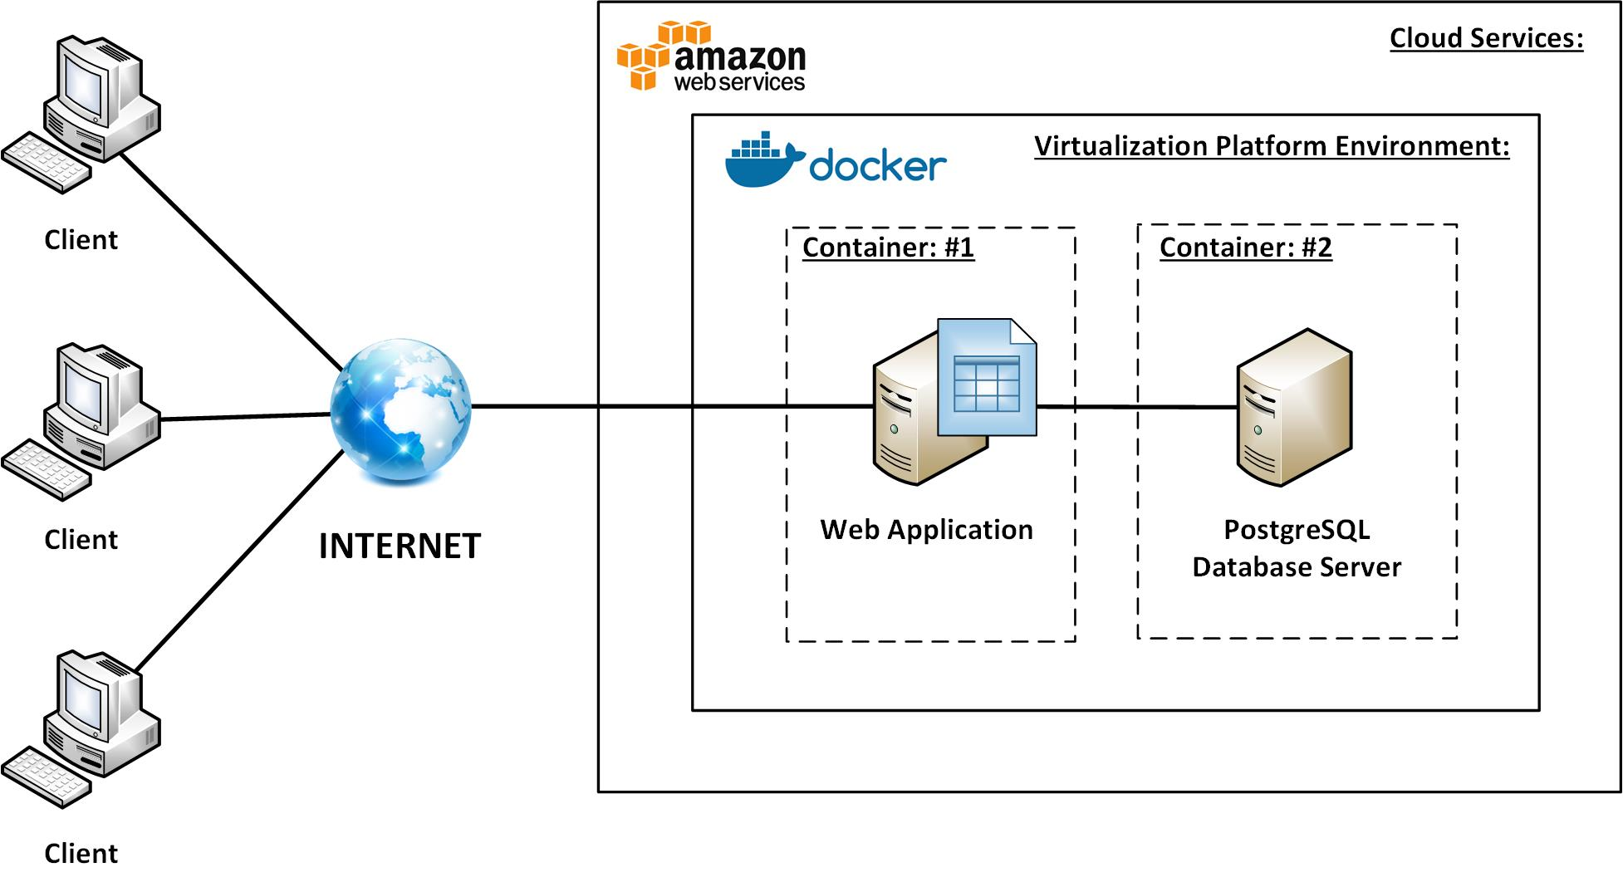
Figure 8: Docker Containers with Clients (Ratz, 2018)

Why Docker:
- Scalability and Flexibility is a big area of focus for the system because the system intends to expand and improve as time goes by, meaning more components will likely be added to the existing structure and set up. These add on components can easily be added by Dockerizing the component and configuring the correct connection links and ports in the Dockerfile to ensure communication is seamless (GeeksForGeeks, 2025).
- Cost effectiveness is ensured because Docker allows lightweight containers to run on a single server without compromising the quality of the overall project (GeeksForGeeks, 2025). Development and deployment costs are reduced because the Docker containers reduce the need for extra, heavy infrastructure to deploy individual components (GeeksForGeeks, 2025).
- Security is enforced because a Docker container cannot access the data of another Docker container without authorization rights (GeeksForGeeks, 2025). This adds a layer of protection around the individual sections of data across the containers set up in the Smart Hydro system.

Oracle VM
With Oracle, the Smart Hydro system makes use of an Ubuntu server where all the Dockerized components live. This limits the system to a single point of failure because the VM can be rebooted in the case of a component experiencing downtime. The VM makes the system easily accessible and understandable to users with less knowledge and technical abilities in the case of handing the ongoing project on to future developers. Figure 9 below shows how an Oracle VM operates with its manager and to an external connecting client:
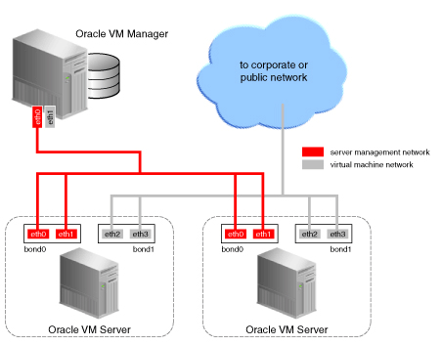
Figure 9: Oracle VM (Oracle Help Centre, 2025)

Cloud security is enforced through a private key that is needed in order to access the VM, meaning only those working on the system will have the key to access the VM and view all the containers hosted on it. The configured ports that are exposed on the VM must be open or the end user accessing the system will not be able to access the VM contents.

TCP and ICMP protocols are implemented where data communication is involved. TCP is used for reliability with a structured sequence of data packets flowing between server and client allowing for testing with traces to identify problem areas in the data traffic as well as error correction when something goes wrong with data transfers (PingPlotter, 2025).

ICMP is used where one component is sending out an ICMP data packet that is carried to another component along with the requirement that the receiving component should return confirmation that the packet has been received (PingPlotter, 2025). This ensures efficient communication between components with back and forth communication indicating successful and failed requests and responses (PingPlotter, 2025).

Why Ubuntu Server:
- Free and open source operating system allows the Smart Hydro system to reduce its lifetime costs when it comes to cloud architecture; the project is intended for farmers who will not be able to afford too costly of a system plus its app to monitor the plants and hydroponics (Nisal, 2025).
- Support for the server ensures that the end of the server uptime is far less of a concern than other platforms because Ubuntu is supported for many years ensuring that the system will continue to run as intended with little chance of shutdown (Wallen, 2024).
- Efficiency in resource management ensures that all the apps on the server will perform outstandingly well, meaning all the Docker containers will run as intended with a smooth performance to ensure Smart Hydro keeps a strong performance for end users (Wallen, 2024).

Mosquitto Broker
The Mosquitto Broker that is hosted on the VM ensures reliable communication between the MQTT and the sensors in the relay box (HiveMQ Team, 2023). It receives the messages from the sensors and undergoes the filtering and distributing process for the message to reach the end user client and the backend client (HiveMQ Team, 2023).

Once topics are subscribed to on the MQTT from the Arduino Controller, the broker becomes responsible for redirecting the messages as needed. The broker set up is handled in the arduino_secrets file from which the broker address and port is pulled into the Arduino and allows the client initialization, broker connection, handshake and finally subscriptions and message publishing (HiveMQ Team, 2023). Figure 10 shows how a client will subscribe to topics and the Mosquitto will publish messages to the MQTT:
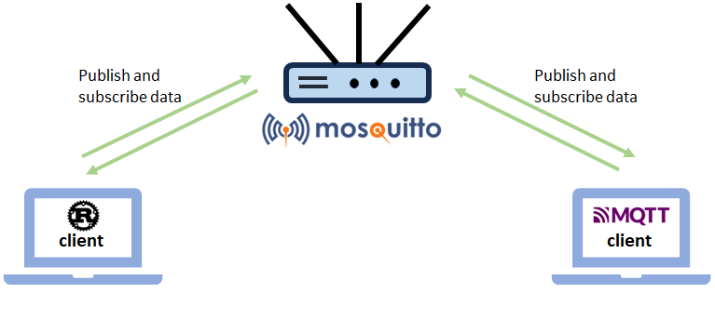
Figure 10: Mosquitto Broker (Trovo, 2024)

Why Mosquitto Broker:
- Lightweight infrastructure allows the broker to require minimal resources to function making it suitable for the sensors and Arduino Controller set up (EMQX Team, 2023). The bandwidth is also used efficiently making it suitable for environments with limited connection (EMQX Team, 2023).
- Multi Platform support enables it to work with the Linux VM and the Dockerized components as well as embedded systems like a Raspberry Pi which is in development for the LoRa development on Smart Hydro (EMQX Team, 2023).
- Message storage means that when a client device is currently not connected and online, the messages intended for that client can be stored to be delivered once the client comes back online which is beneficial in this case where the system is implemented in some limited to low connectivity areas (EMQX Team, 2023).

Architecture Layout
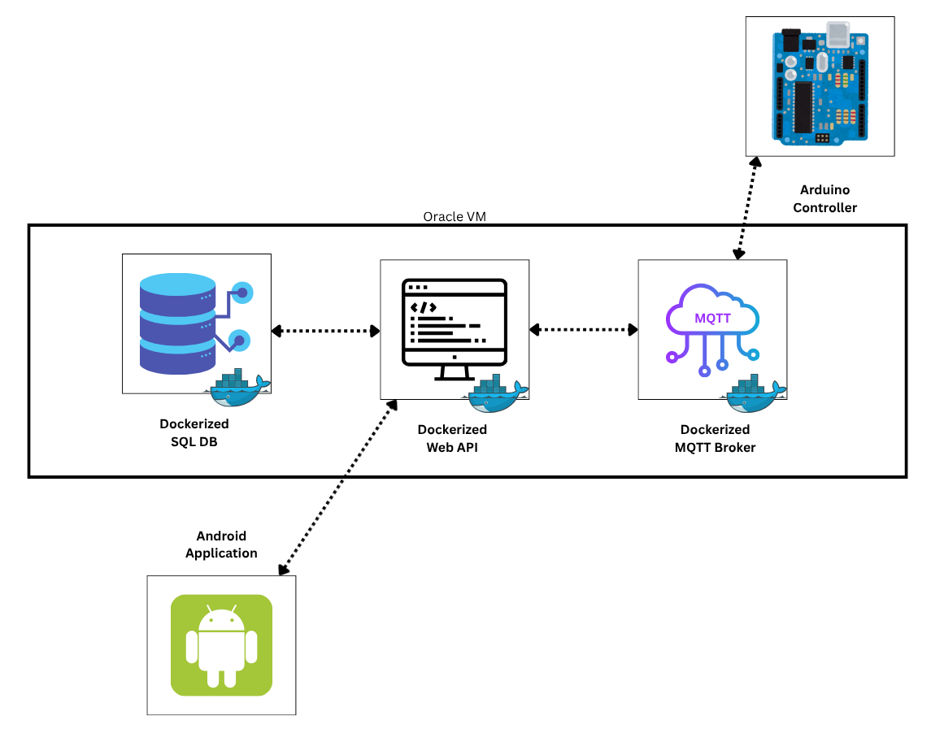
Figure 11: Smart Hydro Infrastructure (Canva, 2025)

Figure 11 above shows an overall view of all components and how they interact with one another throughout the system's lifetime. The Dockerized containers are hosted in the VM where the Arduino Controller will subscribe to topics and publish messages to MQTT which will send data to the API. The API will then request, access and return data from the database to the Android app.

Data Structures
The WebAPI has implemented Dictionary storages to link an object to the respective MAC address of the tent that a component belongs to and the components details being received and sent out. All the Live Cache classes that take data in from the SQL database store and update the data of the objects which include Sensor Readings, Hardware Statuses, AI Events, Tent Information and Camera Images.

The MAC address forms the key to track which readings belong to which tent and makes updating the correct values easier when the current MAC address is tracked throughout the app and passed to the API. Wherever a reading is stored for that tent, for example sensor data, only the matching sensor's object for that specific MAC will be updated and interacted with in the cache class.

Security

Threat actors
As SentinelOne(2025) mentions, threat actors are the perpetrators that do the actual cyber-attacks. Many businesses today want to understand threat actors, due to sophistication of the actors today, and they motivate them to prevent these from exploiting the businesses (SentinelOne, 2025).
In Smart Hydro, there are threat actors that have been identified (SentinelOne, 2025).
- Cybercriminals
These individuals are motivated by financial gain by using technology to conduct illegal activity (SentinelOne, 2025a). For Smart Hydro, these individuals could try to steal the login details to be able to get into the server and steal the data to sell it off to competitive farmers (SentinelOne, 2025a).
- Insider Threat
Insider threats usually do not have malicious intent, but they do exist. Insider threats are employed individuals at the business who may abuse their privilege to access confidential information for gain or damage the business reputation (IBM, 2025). Smart Hydro insider threats could be individuals that work on the farm share tents information with competitive farmers so that they can gain the insight of the data.
- Thrill seekers
These are actors that attack systems just for the fun of it. These attackers don’t want to cause any harm, they can cause damage (IBM, 2025). By interfering with the system network by using techniques, such as inserting scripts, to attack the vulnerabilities and understand how the system works, it can cause future and worst attacks (IBM, 2025; SentinelOne, 2025b). For Smart Hydro, the attacker could use a technique to find the IP address of the server.

Threat vectors
SentinelOne (2025b), explains that a threat vector are pathways that the cyber attacker would follow to gain access to the system and execute cyber-attacks.
      - Ransomware
      - Social Engineering
      - Eavesdropping(MITM)
      - Password Cracking

Implemented Security Measures

Digital Ocean Ubuntu Virtual Machine (VM)
When creating a Droplet in Digital Ocean, it allows users to choose to either access it with a password or a SSH Key.

DevOps and Pipelines
When setting up the Pipelines and the deployment.yml, environmental variables are used. The SEVER_HOST, SERVER_USER, SERVER_PASSWORD, and the MSSQL_SA_PASSWORD are added to the GitHub repository secrets.
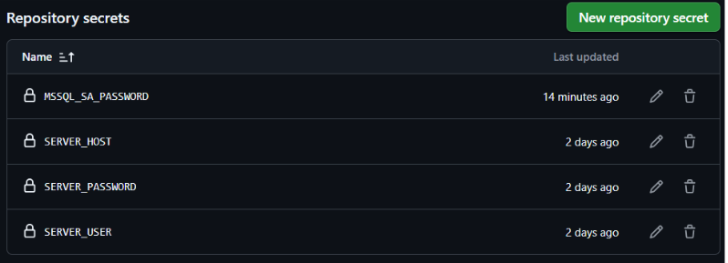

The MQTT Protocol
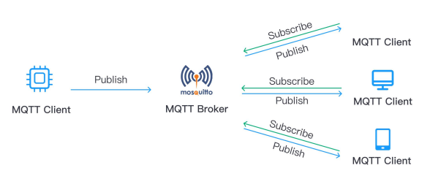

MQTT, mentioned by (Soni and Makwana, 2017) , is a standard messaging protocol, such as publish and subscribe, which is used to communicate securely between machine devices by sending accurate data under long network delay and network conditions with low bandwidth, as shown in figure above (AWS, 2025).

How does the MQTT Work:
MQTT communication protects sensitive data by using a well-known protocol called SSL (Secure Socket Layer). The SSL protocol was created to keep user privacy protected from cyber-attacks (GeeksforGeeks, 2025).
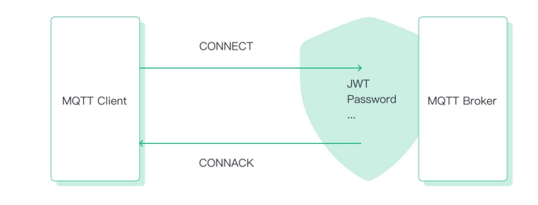

Authentication
The MQTT client authentication is an important method as it forces the clients to provide credentials, which allow an authenticated connection to the MQTT Broker. In the Smart Hydro System, we used an authentication method known as:

Username/Password
The client, which has the correct identification credentials, will provide a username and password, which will be verified by the MQTT Broker to allow or deny a connection (EMQ Technologies, 2023) .
Throughout the system, this method is used. In the Arduino code, there is a "secrets class" that contains the username and password, plus the IP address to connect to the MQTT broker via the Ubuntu Virtual Machine.
In our Web API, we must declare the username and password as well, so that there is communication between the API and the MQTT broker to retrieve information that is displayed on our Android application.

Authorization
In the MQTT Broker, authorization is a process which verifies if the client has the right permissions to either publish or subscribe to a topic (EMQ Technologies, 2023).
Without authorization, authenticated clients will be able to publish and subscribe to any available topics (HiveMQ, 2024).

DevOps
One important task for software development in this project is DevOps. DevOps is the connection between development and operations that allows automation to be performed so that the code can move from development to production quickly, reliably and securely (GeeksForGeeks, 2025).
With the Implementation of Continuous Integration pipeline, using GitHub Actions, we ensure the reliability of Smart Hydro’s system.

Continuous Integration Pipeline
As an individual will update code and push to the GitHub repository, the pipeline will then automatically build up a report that will build the project, run automated tests and also perform security analysis. This will make sure that the code going to the final product will be also secured.

Pipeline Reports

WebAPI Pipeline
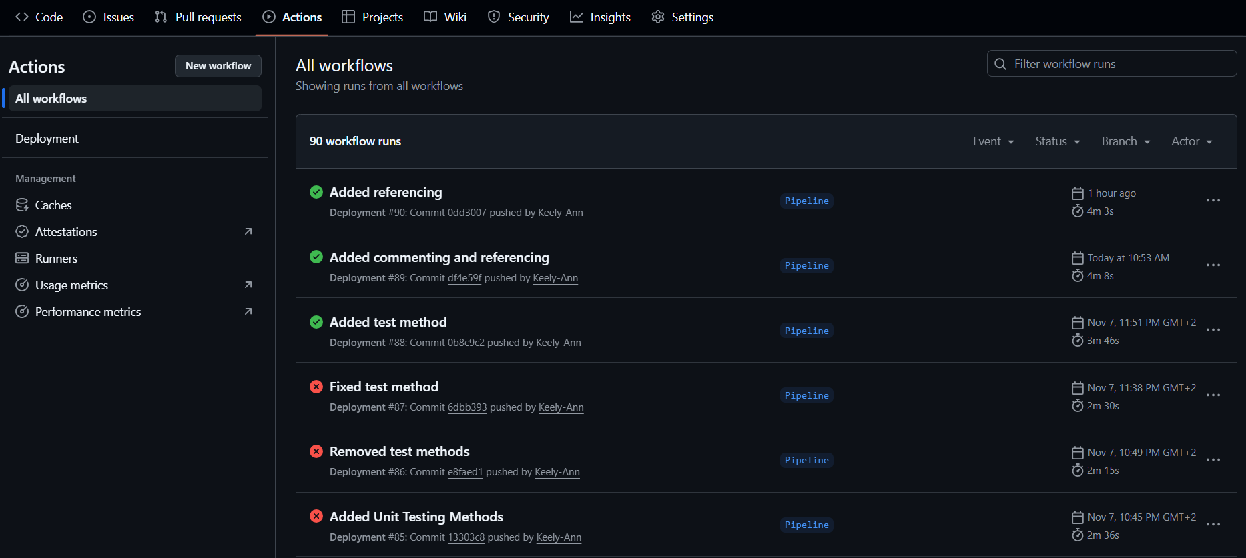

Flow Chart
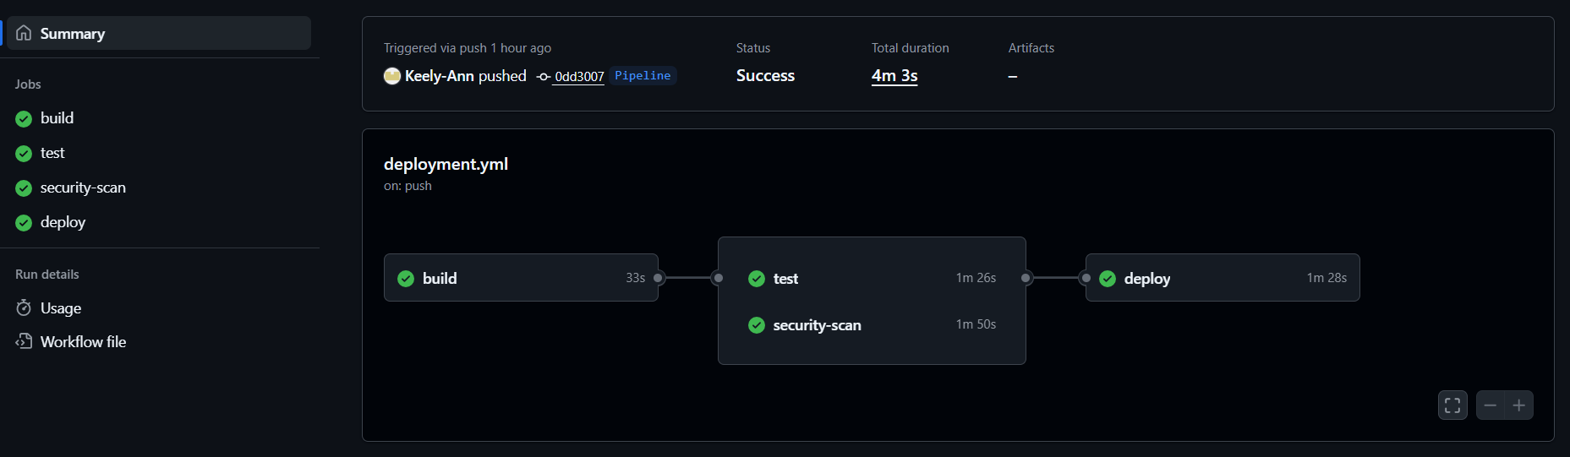

Unit Test
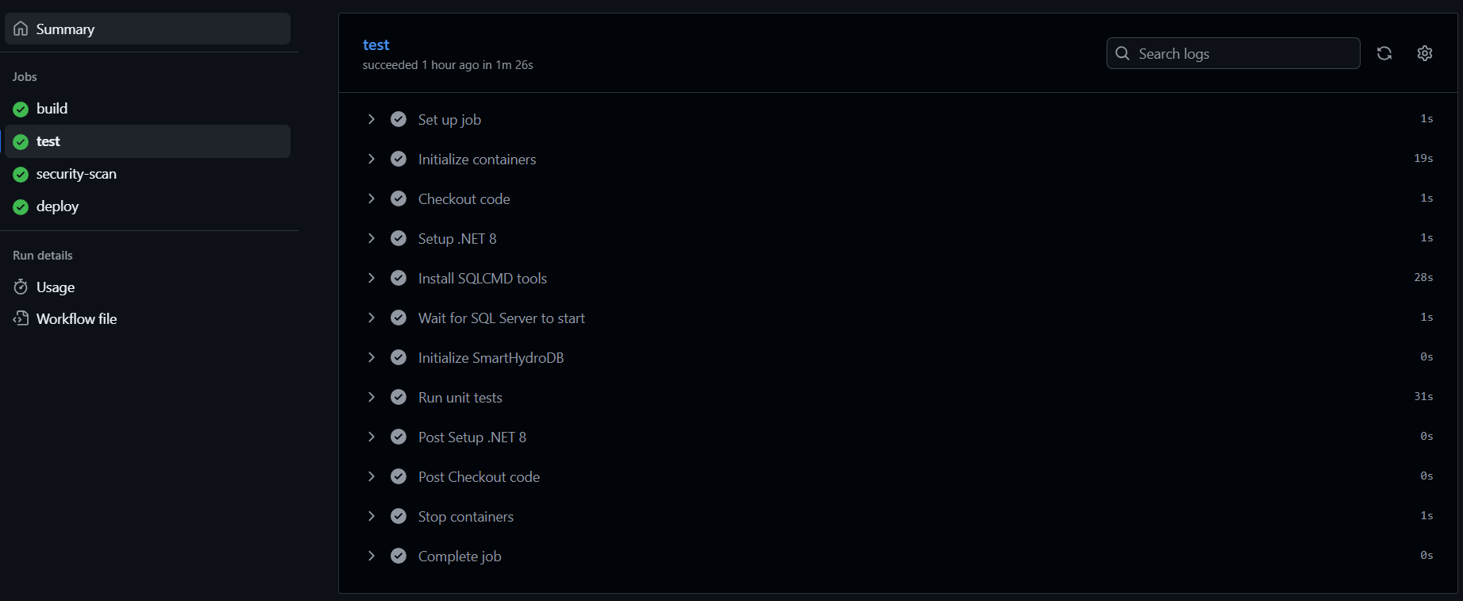

Security Test
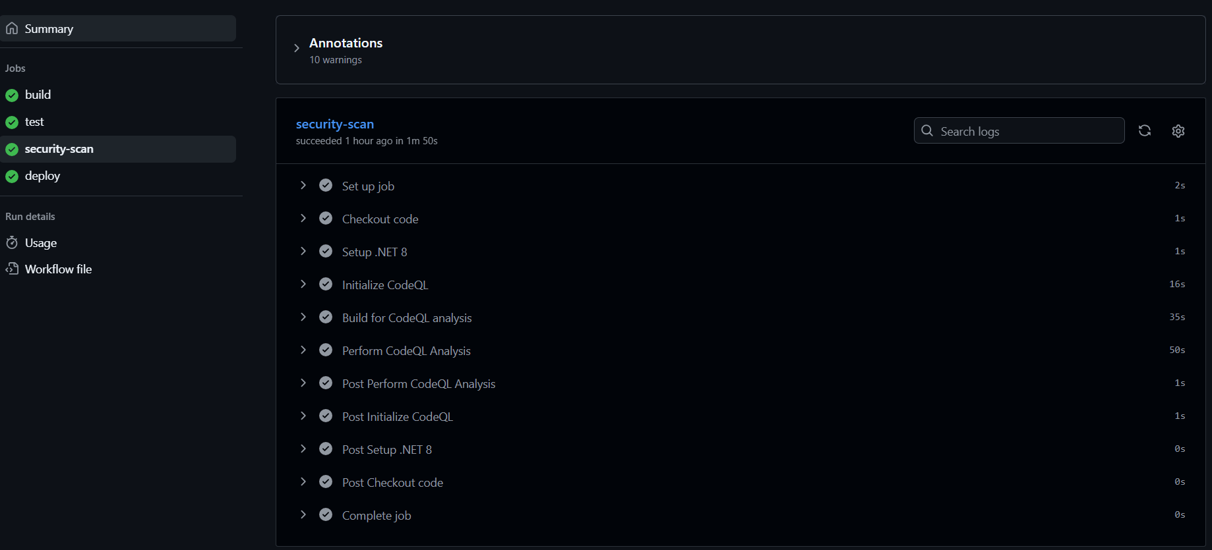
The above figures present the DevOps that took place for the WebAPI.

WebAPI Pipeline Description
The system is setup to automate the build, test, security scan and deployment of the WebAPI onto the Digital Ocean Droplet, using the GitHub Actions Pipelines. The following are dockerised: WebAPI, MQTT Broker and the database. The deployment.yml file is triggered whenever changes are made and pushed to GitHub.
The build in the deployment.yml file pulls the WebAPI repository into the runner and sets up the .NET 8 SDK onto the Droplet, following the downloading of the NuGet packages. The project is then built in the release mode. The unit testing starts the SQL Server container where it runs inside the GitHub Actions. The process waits until the database container is healthy before it executes the database schema script, creating the database. The Xunit test in the test folder, located in the WebAPI, is executed which confirms the tests have passed.
The security scan identifies potential vulnerabilities or code errors. It initializes the CodeQL, builds the project and runs the analysis to generate a security report.
The deployment allows the WebAPI to be deployed to the Digital Ocean Droplet after the tests and security scans have passed. The deployment process is as follows: the docker image is created for the WebAPI locally, the project files are transferred from GitHub to the Digital Ocean Droplet, where the GitHub secrets are used. The Digital Ocean Droplet requires an SSH key to remotely connect to. The docker containers are dropped, rebuilt and restarted using the latest code.
The docker containers share the same network to communicate with each other by name.

Android Pipeline
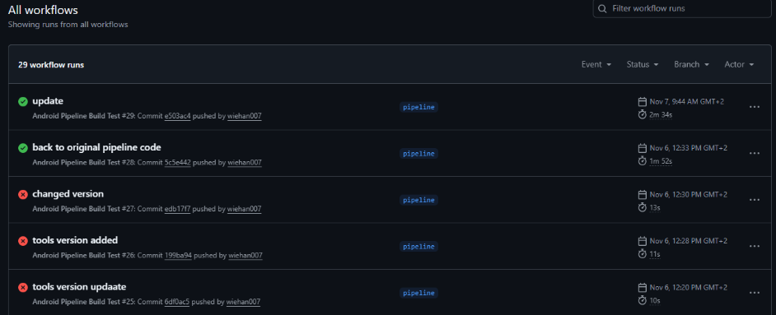

Flow Chart

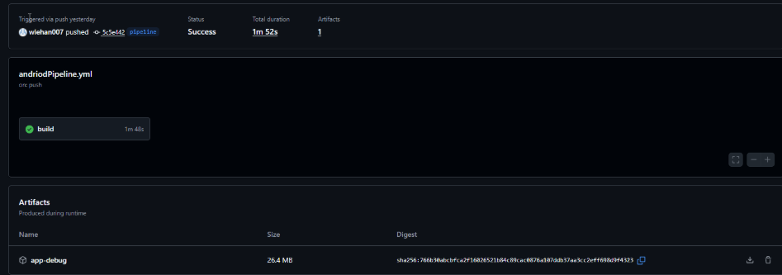

Build Test
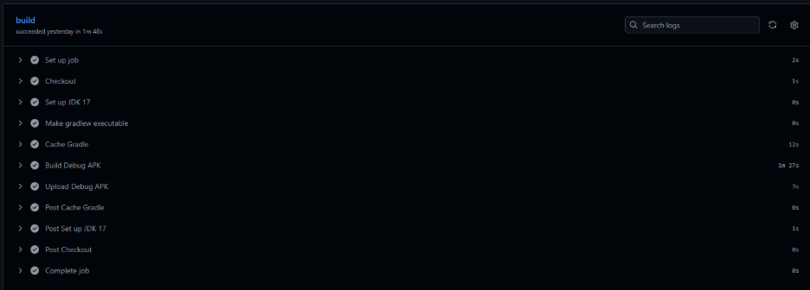
The above figures present the DevOps that took place for the Android.

Android Pipeline Description
GitHub actions start running the pipeline.yml file when there is a push to the specified branch. Then the job will run on ubuntu-latest which is the Linux VM provided by GitHub actions. It will then check the repository into the runner and install Java 17 which must be the same as our project’s JVM. Then it makes the Gradle executable and caches the Gradle afterwards. It will the run any unit tests that we have and after it passes it will build the Debug APK. Finally, the APK will be uploaded as an artifact to GitHub actions where you can download it after the pipeline workflow has finished building.

Running Costs
The section is the costs of the project’s operations.

User growth
Based on the number of tents that have been implemented already.
Year 1: There will be a slow growth of user growth. Now, we have 2 boxes in Namibia, George. Cape Town and Durban. That makes 5 active tents. The growth could go up to 8 active tents.
Year 2: The user growth will pick up. The expansion of the tent boxes can go from maximum 8 active tents to 15 active tents.

Technology Scaling
Scaling is important because as the user growth becomes greater the system should be able to handle these demands (Lenovo, 2025). The main part of the system that would need scaling is the Virtual Machine.

Scaling Infrastructure

Virtual Machine
An estimation is that once the Virtual Machine has reached up to 20 active tents, it should be vertically scaled by upgrading the droplet found in the virtual machine so that the API can still be responsive (Lenovo, 2025).

Mosquitto MQTT Broker
Due to the broker being lightweight and efficient, scaling of this infrastructure wouldn’t be needed until it reached its resource limits of thousands of connections, but not millions (EMQX Team, 2023) . This will be seen when there is a downgrade of performance, such as high latency.

MySQL Database
The database also won’t need quick scaling as it can hold up to millions of records in one table. The only thing is once the performance starts to degrade, then scaling the RAM will help to store all the data in the database (Stack Overflow, 2017)

Alternative Technology

AWS
An alternative for Digital Ocean is Amazon Web Services. Even though AWS is one of the most popular cloud providers, when business start to scale up their cloud infrastructure AWS may become complex and costs will increase even more than Digital Ocean (Adegbuyi, 2025).

EMQX
The EMQX Team (2023), states that EMQX is the better alternative as it supports clustering that allows the system to handle a lot of concurrent connections for large scale

PostgreSQL
PostgreSQL is the alternative to MySQL due to it being highly reliable, performance is strong and is suitable for any structured data storage (Inonos editorial team, 2025). Further, it is highly customizable that allows you to have a lot of flexibility in how to use it. It also offers robust security and can scale up or down, depending on the applications growth (Inonos editorial team, 2025).

Cost Table
The following prices are based on DIYElectronics website (DIYElectronics, 2025). This is from the initial setup.
 | Item | Price
Software
Digital Ocean Ubuntu VM |  | R 207,64
Hardware
Arduino Mega |  | R 434
Power board |  | R 55 x 3 = R165
Bread board |  | R 7 x 3 = R21
SEN0161 pH Sensor V2.0 - Arduino Compatible |  | R 733
Analog Electrical Conductivity Sensor V2 |  | R 1399
Analog Ambient light Sensor Module - Gravity Series |  | R 62
DHT11 V2 Temperature & Humidity Sensor Module - Gravity Series |  | R128
Female to Female SIL Jumper Wires |  | R 19 x 10 = R 190
Male to Female Breadboard Jumpers - 40pcs 21cm |  | R 21 x 10 = R 210
Male to Male Breadboard Jumpers - 40pcs 20cm |  | R 16 x 10 = R 160
Plants
Hydroponics Plants |  | R 220
Total |  | 3 929,64

Monthly Basis (After initial Setup)
 | Item | Price
Software
Digital Ocean Ubuntu VM |  | R 207,64
Total |  | 207,64

Predictive Cost Model
The predictive costs are based on the amounts Digital Ocean (2025).
Period | Best Case | Mean Case | Worst Case
Year 1 | 2 491,68 | 4 983,48 | 19 933,92
Year 2 | 2 491,68 | 4 983,48 | 19 933,92
Grand Total | 4 983,36 | 9 966,96 | 39867,84

- Best Case: 207,64 x 12 = 2 491,68 (2GiB)
- Mean Case: 415,29 x 12 = 4 983,48 (4 GiB)
- Worst Case: 1661,16 x 12 = 19 933,92 (16Gib)

Change Management

How and why will the organization adopt your software?
The organization will adopt the SmartHydro software by initially being ready with the correct hydroponics setup, including all the hardware needed for the relay box, clear documentation on how to setup and install the box as well as the necessary sensors. Once the organization has installed all the necessary hardware, including the relay box, arduino hat and LoRa gateway, with the backend of the SmartHydro software being dockerized, the organization will find it easy to adopt and connect to the software.
As SmartHydro is proven, sustainable and scalable, the organization will be drawn to adopting it. The organization will gain improved efficiency through remote control of their hydroponics system as well as reliable and live data, providing live readings about the conditions within the system.
SmartyHydro will be adopted by the organization as it compliments and promotes the mission of sustainable agriculture in arid and desert regions.

How and why will the users adopt your software?
The users will adopt the SmartHydro software in the form of an Android application. This application will provide access to all readings related to the user's hydroponics system, AI event log readings, as well as the ability to control the tent conditions through toggling the different components on/off or increase/decrease buttons.
The application is simple, effective, user-friendly and has been created with the best interests of the user. With the application incorporating a pull to refresh function on the dashboard page, the user will always have access to the latest readings of their hydroponics system.
Through adopting SmartHydro, the user will have a simplified daily routine in terms of their hydroponics system, while maintaining visibly positive results. Instead of manually checking and making the necessary adjustments to the components, the SmartHydro application will automate most of the work for the user. The user will have many reasons to adopt the SmartHydro software such as ease of use, accessibility, improved results of plant growth and increased automation.

What is your strategy to gain adoption from both the organization and the users?
The strategy to gain adoption from the organization is to begin with an initial implementation of the hydroponic structures. Through a great amount of in-depth documentation, the organization will be able to expand to many different sites once they start to see the first system returning positive results and through learning how to use and set up the system. The documentation covers all bases from installation of the relay box to an in-depth guide on how the application works. The strategy to gain adoption from the users is simply to ensure that positive results are displayed through much testing of the system prior to installation.

Conclusion
In conclusion, the 2025 Smart Hydro group delivered a solution that would enhance the food security for traditional communities, such as those in Namibia.
The main goal of this project was to develop a fully working system that would help farmers connect to their crops that were in hydroponic tents. The group created an Android application, and WebAPI and used Arduino hardware that works together to help run these hydroponics tents. Throughout the development, there were challenges faced due to constraints, such as our LoRa communication which could not be properly implemented.
Furthermore, we also created sustainable architecture for the system. Our backend services, such as the Web API, MySQL database and the Mosquitto MQTT Broker are all hosted in a dockerised environment on our Ubuntu Virtual Machine. This allows our system to be secure, scalable and secure. Moreover, our application was proper thought through as there was use of design patterns and architecture for the Android application and Web API.
This solution will be successfully adopted by the farmers and traditional communities as it will help them to supply nutritious crops for their livestock and clients.

Appendices

Appendix A: Approval Document
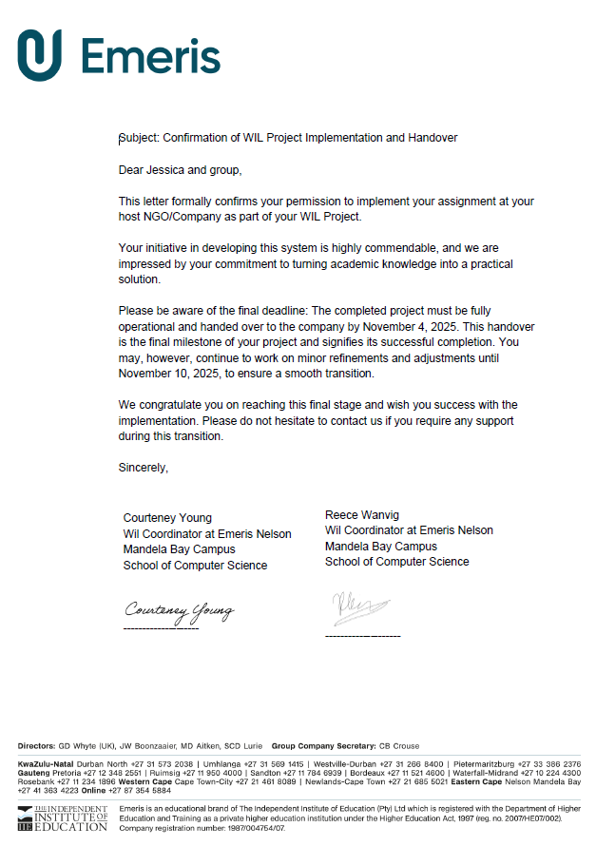

Appendix B: Rubrics

Declaration of Authenticity.


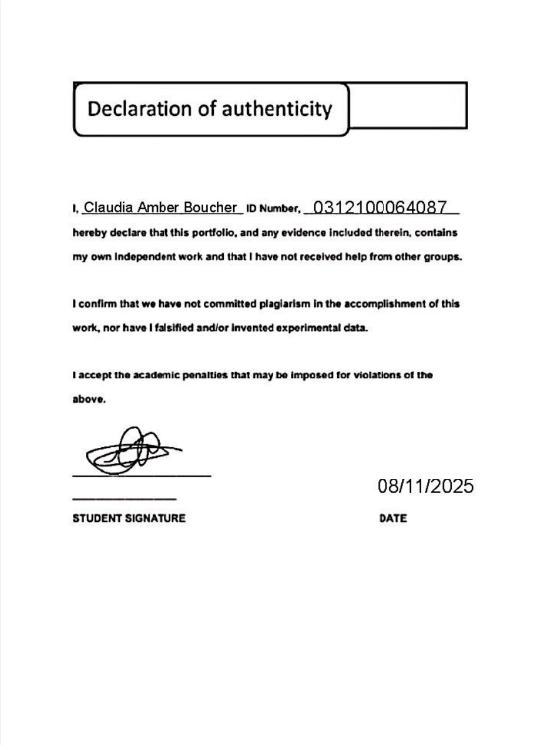


ClickUp Board

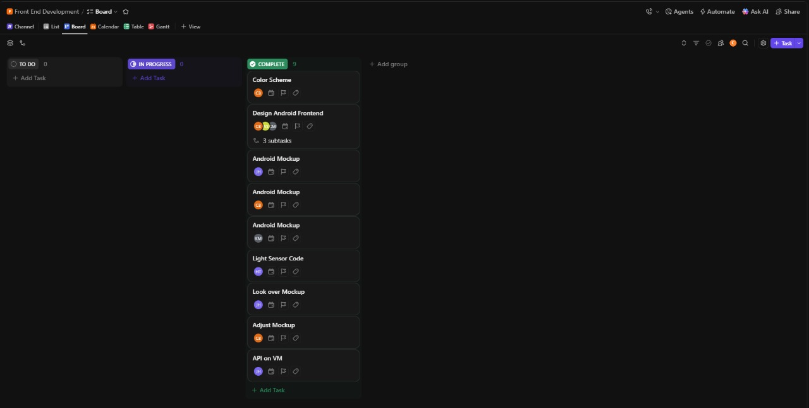
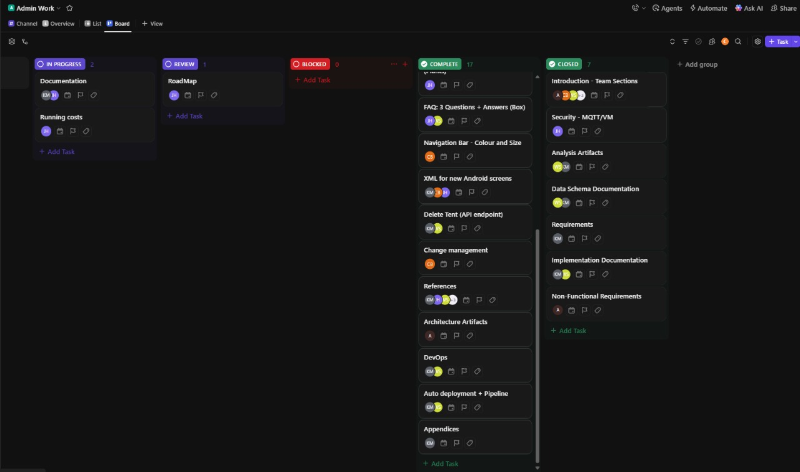

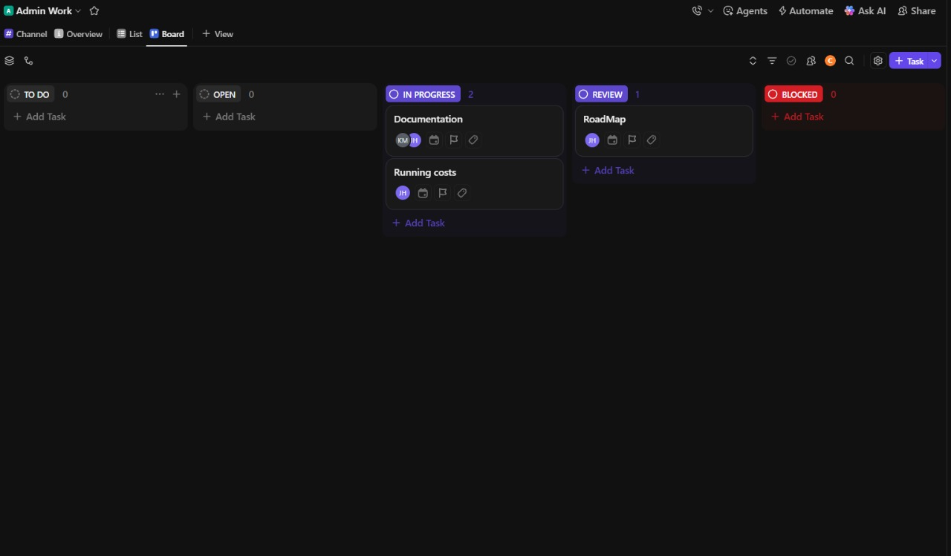
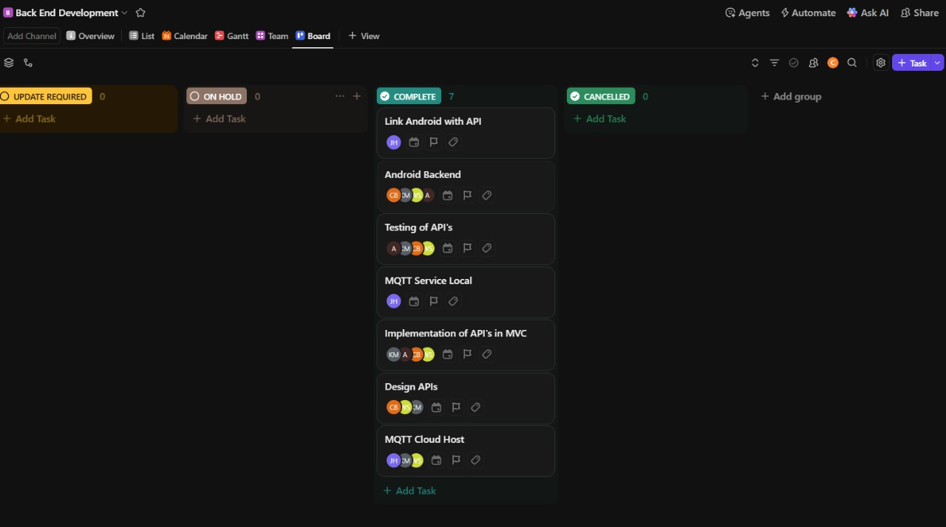

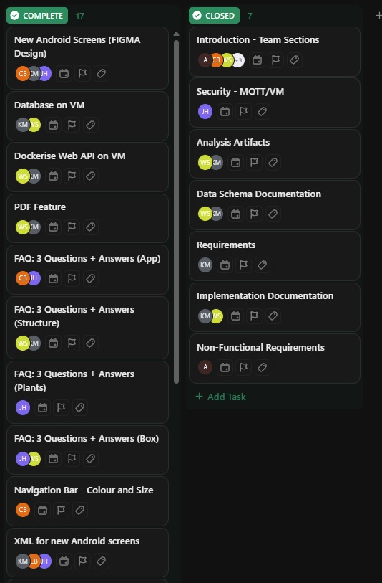

References
Adegbuyi, F. 2025. AWS vs DigitalOcean: Which cloud platform is the best fit for you? [Online]. Available at: https://www.digitalocean.com/blog/aws-vs-digitalocean-cloud-platform#why-digitalocean-over-aws-a-quick-comparison [Accessed 28 October 2025].
Anwar, M. 10 June 2009. Implementing Repository Pattern With Entity Framework. [electronic print]. Available at: < https://www.codeproject.com/articles/Implementing-Repository-Pattern-With-Entity-Fram-2#comments-section > [Accessed 23 October 2025].
AWS, 2025. What is MQTT? [Online]. Available at: < https://aws.amazon.com/what-is/mqtt/#:~:text=a%20WSS%20envelope.-,Is%20MQTT%20secure%3F,data%20transmitted%20by%20IoT%20devices > [Accessed 28 August 2025].
Baeldung. 13 September 2018. Fuel HTTP Library with Kotlin. [Online]. Available at: < https://www.baeldung.com/kotlin/fuel > [Accessed 17 October 2025].
Buglaev, V. 2024. Multi Tier Architecture. [Online]. Available at: <https://medium.com/software-architecture-patterns-and-styles/software-architecture-patterns-and-styles-part-1-multi-tier-architecture-bc5064ea6329 > [Accessed 28 August 2025].
Canva. 2025. Graph (Unlimited). [Online]. Aaviable at: < https://www.canva.com/design/DAG2nU_Mppw/LP7UBttiCMVn_UEJ33hZKw/edit?ui=e30 > [Accessed 23 October 2025].
Cherif, Y. 27 November 2024. Understanding the Layered Architecture Pattern: A Comprehensive Guide. [Online]. Available at: < https://dev.to/yasmine_ddec94f4d4/understanding-the-layered-architecture-pattern-a-comprehensive-guide-1e2j#1-what-is-layered-architecture > [Accessed 3 September 2025].
Cookies, D. 12 September 2024. Observer Design Pattern: A Complete Guide with Examples. [Online]. Available at: < https://devcookies.medium.com/observer-design-pattern-a-complete-guide-with-examples-ec40648749ff > [Accessed 18 October 2025].
Design Gurus Team. 16 October 2024. What is API architecture? [Online]. Available at: < https://www.designgurus.io/answers/detail/what-is-api-architecture > [Accessed 15 September 2025].
Dhaduk, H. 4 July 2020. 10 Software Architecture Patterns You Must Know About. [Online]. Available at: < https://www.simform.com/blog/software-architecture-patterns/ > [Accessed 15 September 2025].
Dhawan,P.,2017.How to make layout with rounded corners.[online] Available at: <android - How to make layout with rounded corners..? - Stack Overflow> [Accessed 20 October 2025].
Digital Ocean, 2025. Virtual Machine(Droplet). [Online]. Available at: https://www.digitalocean.com/pricing/calculator [Accessed 29 October 2025].
DIYElectronics, 2025. DIYElectronics. [Online]. Available at: <https://www.diyelectronics.co.za/store/ > [Accessed 29 October 2025].
dockerdocs, 2025. Install Docker Engine on Ubuntu.[online] Available at: Ubuntu | Docker Docs [Accessed 9 October 2025].
EMQ Technologies Inc., 2023. [pdf] Unlocking the Full Potential of MQTT: A Practical Guide to MQTT Broker Selection. Available at: < https://assets.emqx.com/resources/ebooks/a-practical-guide-to-mqtt-broker-selection.pdf >[Accessed 28 August 2025].
EMQX Team. 21 August 2023. Mosquitto MQTT Broker: Pros/Cons, Tutorial, and Alternative. [Online]. Available at: < https://www.emqx.com/en/blog/mosquitto-mqtt-broker-pros-cons-tutorial-and-modern-alternatives >[Accessed 23 October 2025].
Farley, W. 4 November 2019. Routing Design Patterns. [Online]. Available at: < https://medium.com/@goldhand/routing-design-patterns-fed766ad35fa > [Accessed 17 October 2025].
ForumCosmos, 2023. Ethical Considerations in Data Privacy and Security. . [Online]. Available at: < https://medium.com/@armaanakhan91/ethical-considerations-in-data-privacy-and-security-1874a10061f0 > [Accessed 19 October 2025].
Foxandroid, 2023. Navigation Drawer using Kotlin in Android Studio || Slidable Menu with Navigation Drawer || Kotlin. [video online] Available at: <https://www.youtube.com/watch?v=FbULaP71hXU> [Accessed 18 October 2025].
GeeksforGeeks, 2025. ArrayAdapter in Android with Example. [Online] Available at: <https://www.geeksforgeeks.org/android/arrayadapter-in-android-with-example/> [Accessed 20 October 2025].
GeeksForGeeks, 2025. Navigation Drawer in Android. [online] Available at:<https://www.geeksforgeeks.org/navigation-drawer-in-android/> [Accessed 18 October 2025].
GeeksforGeeks,2025.ArrayAdapter in Android with Example.[online] Available at: <https://www.geeksforgeeks.org/android/arrayadapter-in-android-with-example/>[Accessed 20 October 2025].
GeeksForGeeks. 2025. Secure Socket Layer (SSL). [Online]. Available at: https://www.geeksforgeeks.org/computer-networks/secure-socket-layer-ssl/ [Accessed 28 August 2025].
GeeksForGeeks. 2025. What is DevOps ? [Online]. Available at: < https://www.geeksforgeeks.org/devops/introduction-to-devops/ > [Accessed 28 August 2025].
GeeksForGeeks. 23 July 2025. Why Should You Use Docker - 7 Major Reasons! [Online]. Available at: < https://www.geeksforgeeks.org/blogs/why-should-you-use-docker-7-major-reasons/ >[Accessed 23 October 2025].
Genfer, P. 2025. Repository A Domain-Driven Design Pattern. [Online]. Available at: < https://www.umlboard.com/design-patterns/repository.html > [Accessed 14 October 2025].
GitHub Docs, 2025. Cloning a repository.[online] Available at: Cloning a repository - GitHub Docs [Accessed 9 October 2025].
Grimm, R. 25 September 2022. The Singleton: Pros and Cons. [Online]. Available at: < https://www.modernescpp.com/index.php/singleton-pros-and-cons/ > [Accessed 23 October 2025].
HiveMQ Team. 2024. Authorisation - MQTT Security Fundamentals. [Online]. Available at: < https://www.hivemq.com/blog/mqtt-security-fundamentals-authorization/ > [Accessed 28 August 2025].
Ingalls, S. 17 November 2021. What Is a Client-Server Model? A Guide to Client-Server Architecture. [electronic print]. Available at: < https://www.serverwatch.com/guides/client-server-model/ > [Accessed 23 October 2025].
Ionos editorial Team, 2025. What are the top 6 MySQL alternatives? [Online]. Available at: https://www.ionos.com/digitalguide/server/know-how/mysql-alternatives/ [Accessed 30 October 2025].
Jahagirdar, R. 14 May 2018. Android Http Requests in Kotlin with OkHtpp. [Online]. Available at: < https://medium.com/@rohan.s.jahagirdar/android-http-requests-in-kotlin-with-okhttp-5525f879b9e5 > [Accessed 18 August 2025].
Junhua, W. 20 October 2021. Software Engineering Practices: Strategy Pattern. [Online]. Available at: < https://medium.com/@wenjh1998/software-engineering-practices-strategy-pattern-fb8697cc087c > [Accessed 23 October 2025].
Kartik. 26 September 2025. Observer Design Pattern. [Online]. Available at: < https://www.geeksforgeeks.org/system-design/observer-pattern-set-1-introduction/ > [18 October 2025].
Kartik. 26 September 2025. Strategy Design Pattern. [Online]. Available at: < https://www.geeksforgeeks.org/system-design/strategy-pattern-set-1/ > [Accessed 23 October 2025].
Kindred,B.,2025.Creating Your First CI/CD Pipeline Using GitHub Actions.[online] Available at: Creating Your First CI/CD Pipeline Using GitHub Actions | by Brandon Kindred | Medium [Accessed 27 October 2025].
Kovač,R.,2023,Automating .NET Deployment with GitHub Actions and Docker.[online] Available at: Automating .NET Deployment with GitHub Actions and Docker | by Roko Kovač | Medium [Accessed 27 October 2025].
Lenovo, 2025. What is scale in the context of technology? [Online]. Available at: < https://www.lenovo.com/us/en/glossary/scalling/?orgRef=https%253A%252F%252Fwww.google.com%252F&srsltid=AfmBOoqbSdWsMlmz2dGtcb0sgDuG2FfxJRrIAn85IyFEBCDX__-xpi2s> [Accessed 15 October 2025].
Mahammad, V. 25 October 2020. What is Singleton pattern and what is the advantage of it. [Online]. Available at: < https://medium.com/star-gazers/what-is-singleton-pattern-and-what-is-the-advantage-of-it-43f09509aa7f >[Accessed 23 October 2025].
Mahesh,2015.How do I display an alert dialog on Android.[online] Available at: <How do I display an alert dialog on Android? - Stack Overflow> [Accessed 22 October 2025].
MayorJay,2022.Change of text color of alert dialog.[online] Available at: <android - Change text color of alert dialog - Stack Overflow > [Accessed 23 October 2025].
MindOrks, 2019. How to open a PDF file in Android programmatically. [online] Available at: <How to open a PDF file in Android programmatically?> [Accessed 21 October 2025]
MindOrks,2019.How to open a PDF file in Android programmatically.[online] Available at: <https://blog.mindorks.com/how-to-open-a-pdf-file-in-android-programmatically/> [Accessed 21 October 2025].
Neill, B.,2012. How do you put a border around a ListView.[online] Available at: <android - How do you put a border around a ListView? - Stack Overflow> [Accessed 20 October 2025].
Nisal, N. 15 May 2025. Pros and Cons of Ubuntu. [Online]. Available at: < https://1gbits.com/blog/ubuntu-pros-and-cons/ > [Accessed 23 October 2025].
Oracle Help Centre. 2025. Oracle® VM Concepts Guide for Release 3.4. [electronic print]. Available at: < https://docs.oracle.com/en/virtualization/oracle-vm/3.4/concepts/vmcon-network.html > [Accessed 23 October 2025].
Patel, J. 2024. What is Repository Design Pattern, Pros and cons. [Online]. Available at: < https://www.c-sharpcorner.com/article/what-is-repository-design-pattern-pros-and-cons/ > [Accessed 14 October 2025].
PingPlotter. 2025. Differences Between TCP, UDP, and ICMP. [Online]. Available at: < https://www.pingplotter.com/wisdom/article/packet-type-differences/ > [Accessed 23 October 2025].
Poorte, J. 17 May 2024. C# Strategy Design Pattern. [electronic print]. Available at: < https://www.dofactory.com/net/strategy-design-pattern > [Accessed 23 October 2025].
Ratz, A. V. 21 August 2018. Dockerize A Simple Web-Application Created By Using Python, Flask and PostgreSQL. [electronic print]. Available at: < https://www.codeproject.com/articles/Dockerize-A-Simple-Web-Application-Created-By-Usin#comments-section > [Accessed 23 October 2025].
Refactoring Guru. 2025. Singleton. [Online]. Available at: < https://refactoring.guru/design-patterns/singleton > [Accessed 23 October 2025].
Roddewig, S. 25 July 2025. What Is Event-Driven Architecture? Everything You Need to Know. [electronic print]. Available at: < https://blog.hubspot.com/marketing/event-driven-architecture > [Accessed 23 October 2025].
Seetharamugn. 29 August 2023. The Complete Guide to Event-Driven Architecture. [Online]. Available at: < https://medium.com/@seetharamugn/the-complete-guide-to-event-driven-architecture-b25226594227 > [Accessed 15 September 2025].
Sewani,N.,2018. Android LinearLayout: Add border with shadow around a LinearLayout.[online] Available at: <Android LinearLayout : Add border with shadow around a LinearLayout - Stack Overflow> [Accessed 20 October 2025].
Shanin,S.,2025, Setting Up a CI/CD Pipeline for Android Apps Using GitHub Actions.[online] Available at: https://medium.com/@shahin.cse.sust/setting-up-a-ci-cd-pipeline-for-android-apps-using-github-actions-ee8af55fa674 [Accessed 5 October 2025].
Singh, A. P. 24 June 2024. Singleton Design Pattern and 7 Ways to Implement it. [electronic print]. Available at: < https://blog.algomaster.io/p/singleton-design-pattern > [Accessed 23 October 2025].
SmallAcademy, 2021. Implement Navigation Drawer in Kotlin | Android App Development Tutorial For Beginners. [video online] Available at: <https://www.youtube.com/watch?v=l-jdSOUpSIA> [Accessed 18 October 2025].
Stack Overflow, 2017. How big can a MySQL database get before performance starts to degrade. [Online]. Available at: https://stackoverflow.com/questions/1276/how-big-can-a-mysql-database-get-before-performance-starts-to-degrade [Accessed 20 October 2025].
Tanenbaum, A, S and Wetherall, D. J, 2011. Computer Networks. 5th ed. Boston: Pearson Education.
Tarrade, F.,2019.How to source an entry point script with Docker.[online] Available at: bash - How to source an entry point script with Docker? - Stack Overflow [Accessed 3 November 2025].
Trovo, M. 21 August 2024. How to Leverage Mosquitto MQTT Broker in PHP Project. [electronic print]. Available at: < https://cedalo.com/blog/php-mosquitto-mqtt-broker/ > [Accessed 23 October 2025].
Utbah,M.,2023. ```override fun getView(position: Int, convertView .[online] Available at: < ```override fun getView position Int convertView View parent kotlinlang #android> [Accessed 20 October 2025].
Wallen, J. 24 November 2024. 10 Reasons To Choose Ubuntu Server Over the Competition. [Online]. Available at: < https://thenewstack.io/10-reasons-to-choose-ubuntu-server-over-the-competition/ > [Accessed 23 October 2025].
Zenarmor. 20 May 2023. Client-Server Network: Definition, Advantages, and Disadvantages. [Online]. Available at: <https://www.zenarmor.com/docs/network-basics/what-is-client-server-network > [Accessed 15 September 2025].

